|  |  |
| --- | --- |
|  | Optimization Problems and their Applications |
|  |  |
|  | Naman Bansal and Surendra Beniwal  Guide – Prof. Nitin Padhiyar  10/10/17 |



**Table of Content**

|  |  |  |
| --- | --- | --- |
|  | Theoretical Problems | Engineering Problems |
| LP | 13 | 11, 12 |
| QP | 14, 15 | 21, 22 |
| NLP | 1, 2, 3, 4, 5, 16 | 8, 9, 23 |
| ILP | 17 | 6, 7 |
| INLP | 18, 19 | 10 |
| MINLP | 20 | 24, 25, 26 |

**Example 1** –

A manufacturer needs to make a cylindrical can that will hold 10 m3 of liquid. Determine the dimension of the can that will minimize the cost of material used in used in its construction.

Problem Formulation –

$r$– Radius of cylinder, $h$– Height of cylinder

$V$– Volume of cylinder, $S$– Surface area of cylinder

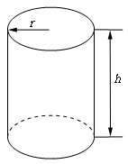

Given –

Cost of Material per unit surface area = C (=1)

Objective –

Determine the dimension of the can that will minimize the cost of material used in used in its construction (Minimum Surface area for given volume of the cylinder)

$$\min_{r,h}{f=2πrh+2πr^{2}}$$

Constraints –

$$V=πr^{2}h≥10$$

Variable Bounds –

$$r>0$$

$$h>0$$

Excel Solution –

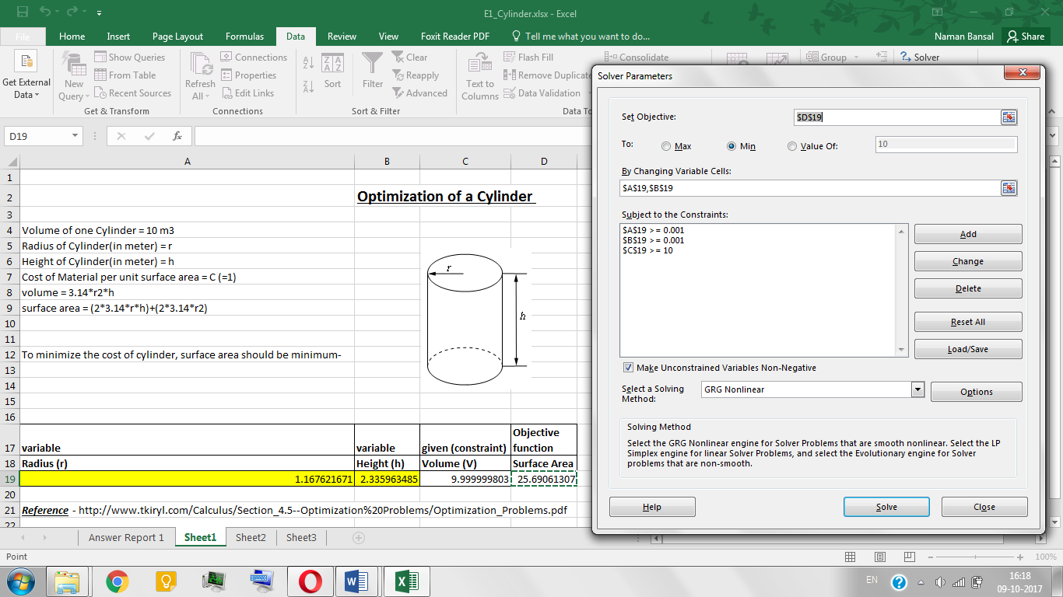

MATLAB Code –

% NLP example  
% Optimization of Cylinder  
% Radius and height of cylinder are variables  
% Reference pg 5 of following document  
% http://www.tkiryl.com/Calculus/Section_4.5--Optimization%20Problems/Optimization_Problems.pdf  
  
function Cylinder()  
  
A=[]; B=[]; % AX<=B  
Aeq=[]; Beq=[]; % AeqX=Beq  
LB = [0;0]; UB=[;]; % lower bound and upper bounds  
% x=[radius(r);height(h)]  
% fval - surface area of Cylinder  
% V - Volume of cylinder  
  
x0 = [0.1;0.1]; % x0 = initial guess radius and height  
  
[x,fval,exitflag] = fmincon(@objfun, x0, A,B,Aeq,Beq,LB,UB,@confun);  
  
r = x(1); % radius of cylinder  
h = x(2); % height of cylinder  
  
disp('Radius of cylinder='), disp(r);  
disp('Height of cylinder='), disp(h);  
disp('Surface area of cylinder='), disp(fval);  
disp('exitflag='); disp(exitflag);  
  
  
function f = objfun(x)  
 % function for defining objective function to be minimized  
  
r = x(1); % radius of cylinder  
h = x(2); % height of cylinder  
  
f =2*pi*r*h+2*pi*r^2; % f - surface area of cylinder  
  
  
function [C, Ceq] = confun(x)  
% function for defining nonlinear constraints  
  
r = x(1); % radius of cylinder  
h = x(2); % height of cylinder  
  
V=10; % volume of cylinder  
C = V-(pi*h*r^2); % C(x)<=0  
Ceq=[]; % Ceq(x)=0

MATLAB Solution –

Radius of cylinder = 1.1675

Height of cylinder = 2.3351

Surface area of cylinder = 25.6950

Exitflag = 1

Reference –

Example 5, page 5 of [document](http://www.tkiryl.com/Calculus/Section_4.5--Optimization%20Problems/Optimization_Problems.pdf)

**Example 2 –**

We want to construct a box whose base length is 3 times the base width. The material used to build the top and bottom cost $10/ft2 and the material used to build the sides cost $6/ft2. If the box must have a volume of 50ft3 determine the dimensions that will minimize the cost to build the box.

Problem Formulation –

$l-$ Length, $w-$ Width, $h-$ Height,

Volume of Cuboid ($V$) $= l*w*h$,

$S1-$ Surface area of top and bottom, $S2-$ Surface area of sides of Cuboid

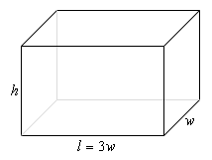

C1 = 10 🡪 (unit cost of material used in the top and bottom of the cuboid)

C2 = 6 🡪 (unit cost of material used in sides of the cuboid)

$S1 = 2*(l*w)$, $S2 = 2*(l*h) + 2*(w*h)$

Objective Function –

$$\min_{l,w,h}{f=(\left(S1*C1\right)+\left(S2*C2\right))}$$

Constraints –

$$V≥50 m^{3}$$

$$l=3*w$$

Variable Bounds –

$$w,h>0$$

Excel Solution –

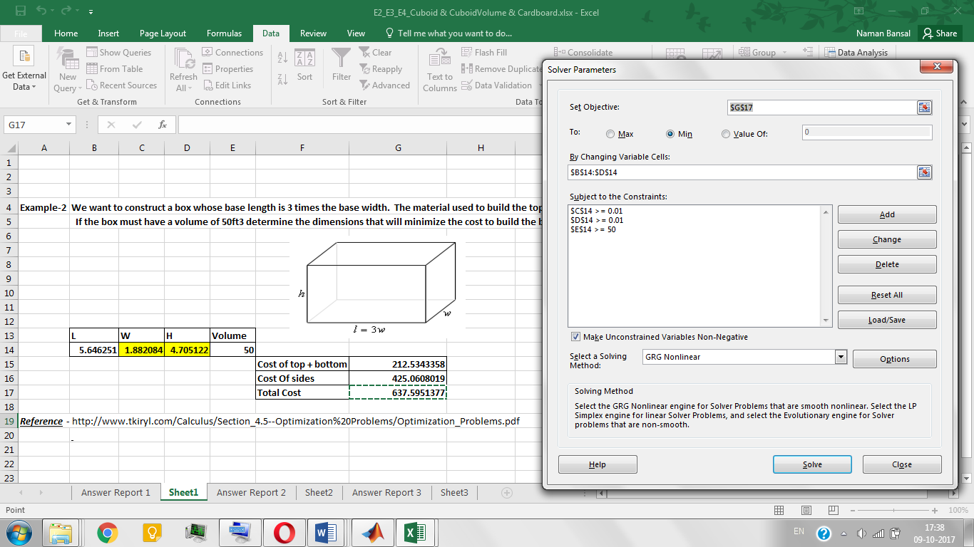

MATLAB Code –

% NLP Example  
% Minimum cost for atleast 50 m3 cuboid volume  
% height and width are the variables  
% Reference pg 3 of the following document  
% http://www.tkiryl.com/Calculus/Section_4.5--Optimization%20Problems/Optimization_Problems.pdf  
  
 function Cuboid()  
A = []; B = []; % Ax<=B  
Aeq = []; Beq = []; % Aeq=beq  
LB = [0;0]; UB = [ ; ]; % lower bound and upper bounds  
  
% x = [width(w); height(h)]  
x0 = [0.1;0.1]; % inital guess of width and height  
  
  
[x,tc, exitflag] = fmincon(@objfun,x0,A,B,Aeq,Beq,LB,UB,@confun);  
  
% tc - total cost  
% given -> length = 3*width  
% exitflag >0 ==> the solution is reliable  
  
w = x(1); % width of the cuboid  
h = x(2); % height of the cuboid  
l=3*w; % length of the cuboid  
V=l*w*h; % volume of the cuboid  
  
disp('width='); disp(w);  
disp('height='); disp(h);  
disp('length='); disp(l);  
disp('volume='); disp(V);  
disp('total cost='); disp(tc);  
disp('exitflag='); disp(exitflag);  
  
function f = objfun(x)  
% function for defining objective function to be minimized  
  
w = x(1); % width of the cuboid  
h = x(2); % height of the cuboid  
l=3*w; % length of the cuboid  
  
%total cost= (surface area of top and bottom)*10  
% + (suraface area of sides)*6  
S1 = 2*l*w; % surface area of top and bottom  
S2 = 2*(l*h) + 2*(w*h); % suraface area of sides  
C1= 10; % unit cost of the material used in the top and bottom surface of the cuboid  
C2= 6; % unit cost of the material used in the side surface of the cuboid  
  
f = S1*C1 + S2*C2 ; % total material cost  
  
  
function [C,Ceq] = confun(x)  
% function for defining nonlinear constraints  
w = x(1); % width of the cuboid  
h = x(2); % height of the cuboid  
l=3*w; % length of the cuboid  
  
V = 50; % volume of the cuboid  
  
C = V-(l*w*h); % C(x)<=0  
Ceq = []; % Ceq(x)=0

MATLAB Solution –

Length = 5.6462

Width = 1.8821

Height = 4.7052

Total cost = 637.5952

Exitflag = 1

Reference –

Example 3, page 3 of [document](http://www.tkiryl.com/Calculus/Section_4.5--Optimization%20Problems/Optimization_Problems.pdf)

**Example 3 –**

We want to construct a box with a square base and we only have 10 m2 of material to use in construction of the box. Assuming that all the material is used in the construction process determine the maximum volume that the box can have.

Problem Formulation –

$l-$ Length, $w-$ Width, $h-$ Height,

Volume of Cuboid ($V$) $=l*w*h$,

Surface area of top and bottom ($S$) $= 2*((l*w) + (w*h) + (l*h))$

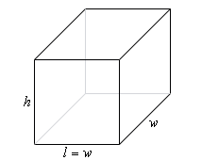

Objective Function –

$$\max_{l,w,h}{f=l*w*h}$$

Constraints –

$$S=10 m^{2}$$

Variable Bounds –

$$l,w,h>0$$

Excel Solution –

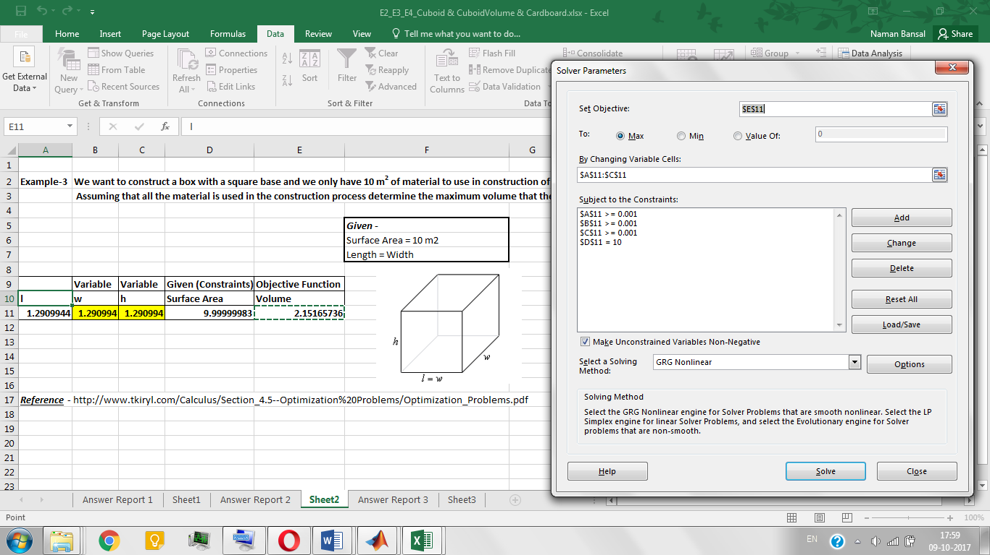

MATLAB Code –

% NLP example  
% For given surface area, maximum cuboid volume  
% Height and width of cuboid are variables  
% length is equal to width  
% Reference pg 4 of following document  
% http://www.tkiryl.com/Calculus/Section_4.5--Optimization%20Problems/Optimization_Problems.pdf  
  
function CuboidVolume()  
A = []; B = []; % Ax<=B  
Aeq = []; Beq = []; % Aeq=Beq  
LB = [0;0]; UB = [ ; ]; % lower bound and upper bound  
  
x0 = [0.1;0.1]; % inital guess of width and height  
% x = [width(w); height(h)]  
% V = volume of cuboid  
  
[x,V,exitflag] = fmincon(@objfun,x0,A,B,Aeq,Beq,LB,UB,@confun);  
  
% given -> length = width  
w = x(1); % width of the cuboid  
h = x(2); % height of the cuboid  
l = w; % length of the cuboid  
  
 disp('length='); disp(l);  
 disp('width='); disp(w);  
 disp('height='); disp(h);  
 disp('Volume='); disp(-V);  
 disp('exitflag='); disp(exitflag);  
  
  
function f = objfun(x)  
% function for defining objective function to be maximized  
  
w = x(1); % width of the cuboid  
h = x(2); % height of the cuboid  
l = w; % length of the cuboid  
  
% volume = length * width * height  
  
f = -(l*w*h);  
  
function [C,Ceq] = confun(x)  
% function for defining nonlinear constraints  
  
w = x(1); % width of the cuboid  
h = x(2); % height of the cuboid  
l = w; % length of the cuboid  
S = 10; % surface area of the cuboid  
  
Ceq =-S + 2*((l*w)+(l*h)+(w*h)); % Ceq(x)=0  
C = []; % C(x)<=0

MATLAB Solution –

Length = 1.2910

Width = 1.2910

Height = 1.2910

Volume = 2.1517

Exitflag = 1

Reference –

Example 4, page 4 of [document](http://www.tkiryl.com/Calculus/Section_4.5--Optimization%20Problems/Optimization_Problems.pdf)

**Example 4 –**

We have a piece of cardboard that is 14 inches by 10 inches and we’re going to cut out the corners as shown below and fold up the sides to form a box, also shown below. Determine the height of the box that will give a maximum volume.

Problem Formulation –

Length ($l$) $=10-2*h$,

Width ($w$) $=14-2*h$,

$h-$ Height,

Volume of cuboid ($V$) $=l*w*h$

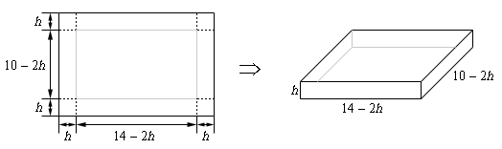

Objective Function –

Determine the dimension of box that will maximize the volume.

$$\max_{h}{f=(10-2*h)*(h)*(14-2*h)}$$

Variable Bounds –

$$h>0$$

Excel Solution –

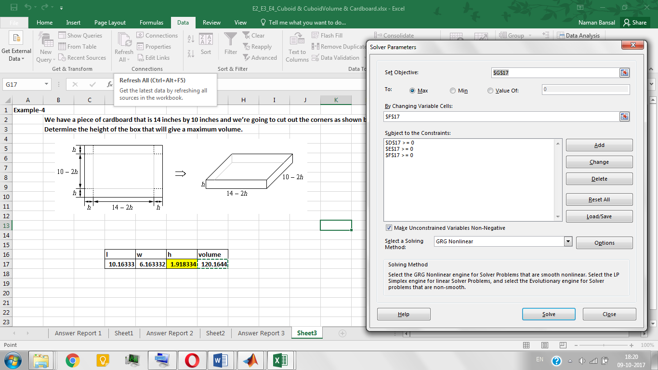

MATLAB Code –

% NLP example  
% Maximum volume of cuboid made by using a Cardboard  
% Height of the cuboid is variable  
% Reference pg 6 of following document  
% http://www.tkiryl.com/Calculus/Section_4.5--Optimization%20Problems/Optimization_Problems.pdf  
  
function Cardboard()  
A = []; B = []; % Ax<=B  
Aeq = []; Beq = []; % Aeq=Beq  
LB = [0]; UB = [5]; % lower bound and upper bound  
  
% x = [width(w); height(h)]  
  
x0 = [0]; % inital guess of height  
  
% x = [height(h)]  
% V = volume of cuboid  
  
[x,V,exitflag] = fmincon(@objfun,x0,A,B,Aeq,Beq,LB,UB);  
  
h=x; % height of the cuboid  
l = 10-2*x; % length of the cuboid  
w = 14-2*x; % width of the cuboid  
  
disp('length='); disp(l);  
disp('width='); disp(w);  
disp('height='); disp(h);  
disp('Volume='); disp(-V);  
disp('exitflag='); disp(exitflag);  
  
function f = objfun(x)  
% function for defining objective function to be maximized  
h=x; % height of the cuboid  
l = 10-2*x; % length of the cuboid  
w = 14-2*x; % width of the cuboid  
  
% volume = length * width * height  
  
f = -(l*w*h);

MATLAB Solution –

Length = 6.1633

Width = 10.1633

Height = 1.9183

Volume = 120.1644

Exitflag = 1

Reference –

Example 6, page 6 of [document](http://www.tkiryl.com/Calculus/Section_4.5--Optimization%20Problems/Optimization_Problems.pdf)

**Example 5 –**

Farmer has 2400 ft. of fencing and wants to fence off a rectangular field that borders a building. He needs no fence along the river. What are the dimensions of the field that has the largest area?

Problem Formulation –

$l-$ Length, $w-$ Width,

Available fence material/Perimeter ($P$) $=l+2*w$

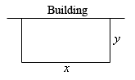

Objective Function –

Determine the dimensions of the field that has the largest area.

$$\max_{l,w}{f=l*w}$$

Constraints –

$$P=2400$$

Variable Bounds –

$$l,w>0$$

Excel Solution –

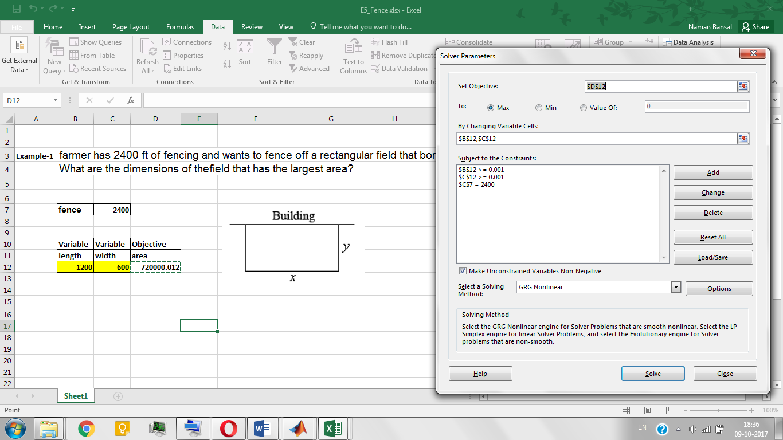

MATLAB Code –

% NLP Example  
% Covering maximum rectangle area with given fence material  
% length and width are variables  
% Reference pg 1 of following document  
% http://www.tkiryl.com/Calculus/Section_4.5--Optimization%20Problems/Optimization_Problems.pdf  
 function Fence()  
A = []; B = []; % Ax<=B  
Aeq = []; Beq = []; % Aeq=Beq  
LB = [0;0]; UB = [ ; ]; % lower bound and upper bound  
  
x0 = [0.1;0.1]; % inital guess of length and width  
% x = [length(l); width(w)]  
% a - area covered by fence  
  
[x,a,exitflag] = fmincon(@objfun,x0,A,B,Aeq,Beq,LB,UB,@confun);  
  
l = x(1); % length of the cuboid  
w = x(2); % width of the cuboid  
  
 disp('length='); disp(l);  
 disp('width='); disp(w);  
 disp('maximum rectangular area covered by fence='); disp(-a);  
 disp('exitflag='); disp(exitflag);  
  
function f = objfun(x)  
% function for defining objective function to be maximized  
l = x(1); % length of the cuboid  
w = x(2); % width of the cuboid  
  
f = -(l*w); % area = length*width  
  
  
function [C,Ceq] = confun(x)  
% function for defining nonlinear constraints  
l = x(1); % length of the cuboid  
w = x(2); % width of the cuboid  
p = 2400; % perimeter (available fence material) = (length + 2*width)  
  
C = []; % C(x)<=0  
Ceq = p-(l+(2*w)); % Ceq(x)=0

MATLAB Solution –

Length = 1.2000e+03

Width = 600.0000

Maximum rectangular area covered by fence = 7.2000e+05

Exitflag = 1

Reference –

Example 6, page 6 of [document](http://www.tkiryl.com/Calculus/Section_4.5--Optimization%20Problems/Optimization_Problems.pdf)

**Example 6** –

Bryant's Pizza, Inc. is a producer of frozen pizza products. The company makes a net income of $1.00 for each regular pizza and $1.50 for each deluxe pizza produced. The firm currently has 600 pounds of dough mix and 200 pounds of topping mix. Each regular pizza uses 4 pound of dough mix and 1 pound of topping mix. Each deluxe pizza uses 2 pound of dough mix and 1 pound of topping mix. Based on the past demand per week, Bryant can sell at least 50 regular pizzas and at least 25 deluxe pizzas. The problem is to determine the number of regular and deluxe pizzas the company should make to maximize net income. Formulate this problem as an LP problem.

Problem Formulation –

|  |  |  |  |
| --- | --- | --- | --- |
|  | Total amount available | Per unit used for Regular Pizza(R) | Per unit used for Deluxe Pizza(D) |
| Dough Mix (DM) | 600 | 4 | 2 |
| Topping mix (TM) | 200 | 1 | 1 |

Objective Function –

$$\max_{R,D}{f=\left(R*1\right)+(D*1.5)}$$

Constraints –

$$R≥50$$

$$D≥25$$

$$DM≤600$$

$$TM≤200$$

Excel Solution –

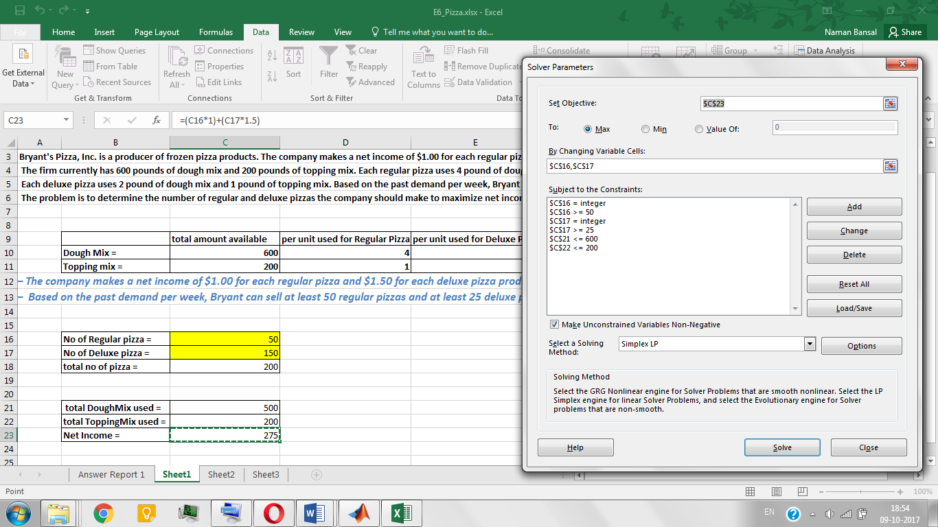

MATLAB Code –

% ILP example  
% selling different types of pizza for maximum net income  
% Reference http://home.ubalt.edu/ntsbarsh/opre640A/partVIII.htm  
  
A = [4 2; 1 1;-1 0;0 -1]; B = [600;200;-50;-25]; % Ax<=B  
  
Aeq = [0,0;0,0;0,0]; Beq = [0;0;0]; % Aeq=Beq  
  
lb = [0,0]; ub = [ , ]; % lower bound and upper bound  
  
% Net Income= no of regular pizza * 1 + no of deluxe pizza * 1.5  
ni = -[1,1.5]; % ni(1) = net income from regular pizza  
 % ni(2) = net income from deluxe pizza  
  
x = [ ; ]; % x = [regular pizza(r); deluxe pizza(d)]  
  
intcon = [1,2]; % no of regular pizza(x(1)) and deluxe pizza(x(2)) are integer  
  
[x,ni,exitflag] = intlinprog(ni,intcon,A,B,Aeq,Beq,lb,ub);  
  
r = x(1); % no of regular pizza  
d = x(2); % no of deluxe pizza  
  
 disp('No of Regular Pizza='); disp(r);  
 disp('No of Deluxe Pizza='); disp(d);  
 disp('Net Income='); disp(-ni);  
 disp('exitflag='); disp(exitflag);

MATLAB Solution –

No. of Regular Pizza = 50.0000

No. of Deluxe Pizza = 150

Net Income = 275

Exitflag = 1

Reference –

<http://home.ubalt.edu/ntsbarsh/opre640A/partVIII.htm>

**Example 7 –**

Suppose the only foods available to you are potatoes and Apple. The decision about how much of each food to buy is made entirely on the basis of dietary and economic considerations.

We have the nutritional and cost information in the following table:

|  |  |  |  |
| --- | --- | --- | --- |
|  | Per unit of potatoes (P) | Per unit of apple (A) | Minimum requirements |
| Units of carbohydrates(CA) | 2 | 1 | 9 |
| Units of vitamins(VI) | 4 | 4 | 20 |
| Units of proteins(PR) | 1 | 4 | 6 |
| Unit cost | 30 | 45 |  |

Problem Formulation –

$P-$ Number of potatoes

$N_{a}-$ Number of apples

$A-$ Unit cost of potatoes

$C_{a}-$ Unit cost of apples

Total cost ($C$) $=P*C_{p}+A*C_{a}$

Objective Function –

$$\min_{P,A}{f=\left(P*30\right)+(A*45)}$$

Constraints –

$$CA≥9, VI≥20, PR≥6$$

Excel Solution –

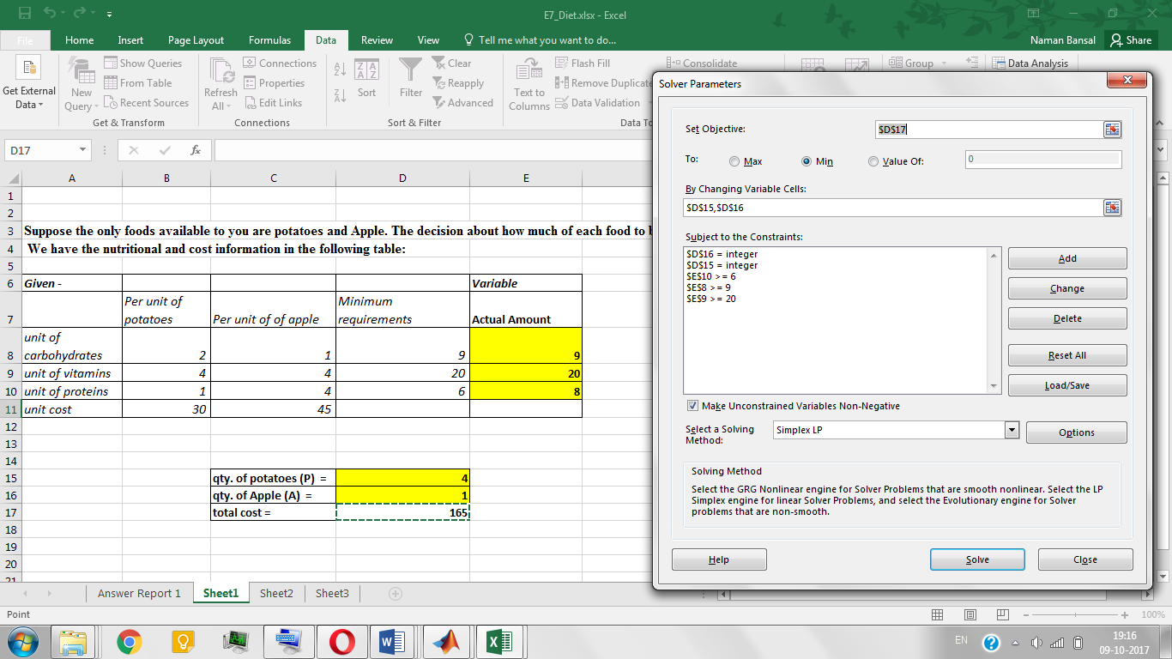

MATLAB Code –

% ILP example  
% Buying food with dietary and economic considerations  
% Reference http://home.ubalt.edu/ntsbarsh/opre640A/partVIII.htm  
  
A = -[2 1; 4 4; 1 4]; B = -[9;20;6]; % Ax<=B  
  
Aeq = [0,0;0,0;0,0]; Beq = [0;0;0]; % Aeq=Beq  
  
lb = [0,0]; ub = [ , ]; % lower bound and upper bound  
  
% total cost= no of potatoes*30 + no of apples*45  
tc = [30,45]; % tc(1) = cost of a potato  
 % tc(2) = cost of a apple  
  
x = [ ; ]; % x = [potatoes(p); Apples(a)]  
  
intcon = [1,2]; % no of potatoes(x(1)) and apples(x(2)) are integer  
  
[x,tc,exitflag] = intlinprog(tc,intcon,A,B,Aeq,Beq,lb,ub);  
  
p = x(1); % no of potatoes  
a = x(2); % no of apples  
  
 disp('no of potatoes='); disp(p);  
 disp('no of apples='); disp(a);  
 disp('total cost='); disp(tc);

MATLAB Solution –

No. of potatoes = 4.0000

No. of apples = 1.0000

Total cost = 165.0000

Exitflag = 1

Reference –

<http://home.ubalt.edu/ntsbarsh/opre640A/partVIII.htm>

**Example 8 –**

Determine the optimum economic thickness of insulation that should be used under the following conditions: Saturated steam is being passed continuously through a steel pipe with an outside diameter of 10.75 in. The temperature of the steam is 400°F, and the steam is valued at $1.80 per 1000 lb. The pipe is to be insulated with a material that has a 0.03 Btu/(h)(ft2)( °F/ft). The cost of the installed insulation per foot of pipe length is $4.5 x I, where I is the thickness of the insulation in inches. Annual fixed charges including maintenance amount to 20 percent of the initial installed cost. The total length of the pipe is 1000 ft, and the average temperature of the surroundings may be taken as 70°F. Heat-transfer resistances due to the steam film, scale, and pipe wall are negligible. The air-film coefficient at the outside of the insulation may be assumed constant at 2.0 Btu/ (h)(ft2)(°F) for all insulation thickness.

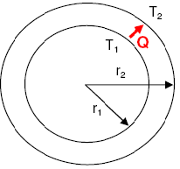

Problem Formulation –

Heat transfer by conduction in pipe ($Q$) $=2πkL\frac{(T1-T2)}{\ln{(\frac{r2}{r1})}}$

Outer radius of the pipe ($r2$) $=r1*e^{\frac{Q}{2πkL(T1-T2)}}$

$I-$ Insulation thickness

Outside Diameter ($Do$) = 10.75 in.

Temperature of steam ($T1$) = 400 °F

Thermal Conductivity of insulation material ($k$) = 0.03 Btu/(h)(ft2)( °F/ft)

Price of installed insulation (per unit thickness of insulation) ($P_{I}$) = 4500 $/in.

Total length of Pipe ($L$) = 1000 ft

Temperature of surrounding ($T2$) = 70 °F

Air-film coefficient ($h$) = 2 Btu/(h)(ft2)( °F)

Latent Heat of steam (at 400 °F) = 826 Btu/lb

Price of steam (per 1000 lb) = 1.8 $

Total Cost of Insulation Material ($Ci$) $=P_{I}*I$

Total Annual Fixed Cost (including maintenance) ($Caf$) $=Ci*\frac{20}{100}$

Total Cost of Steam ($Cs$) $=\left(\frac{\left(T1-T2\right)}{\left(\frac{\ln\left(\frac{Do}{\left(Do+2*I\right)}\right)}{2πLk}\right)+\left(\frac{1}{h*\left(π\left(Do+2I\right)L\right)}\right)}\right)*\left(\frac{\left(price of steam\right)*24*365}{latent heat of steam}\right)$

Objective Function –

$$\min_{I}{f=(Ci+Caf+Cs)}$$

Variable Bounds –

$$I≥0$$

Excel Solution –

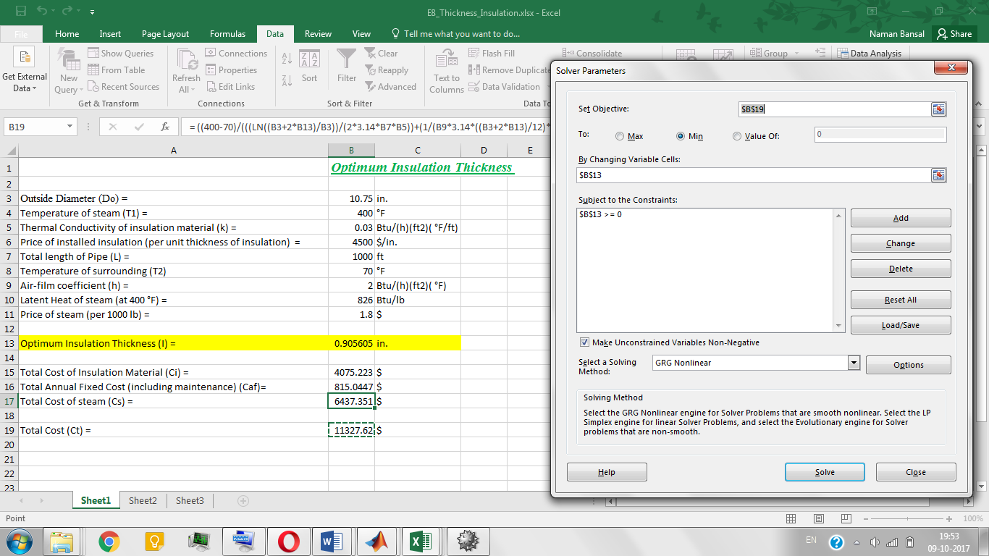

MATLAB Code –

% NLP example  
% Optimization of insulation material thickness over a pipe  
% Insulation thickness is variable  
% Reference pg 430, problem 2 of following book "PLANT DESIGN AND ECONOMICS  
% FOR CHEMICAL ENGINEERS" BY MAX S. PETERS and KLAUS D.TIMMERHAUS  
  
function Insulation_thickness()  
A = []; B = []; % Ax <= B  
Aeq = []; Beq = []; %AeqX = Beq  
LB = [0]; UB = []; % lower bound and upper bound  
x0 = [0]; % initial guess  
% x - insulation thickness  
% fval - optimum cost  
  
[x,fval,exitflag] = fmincon(@objfun,x0,A,B,Aeq,Beq,LB,UB);  
  
disp('optimum insulation thickness'); disp(x);  
disp('total minimum cost'); disp(fval);  
disp('exitflag'); disp(exitflag);  
  
function f = objfun(x)  
Do = 10.75; % outside diameter of pipe (inch)  
T1 = 400; % temperature of the steam (°F)  
T2 = 70; % temperature of the surrounding (in °F)  
k = 0.03; % thermal conductivity of insulation material (Btu/(h)(ft2)(°F/ft))  
P = 4500; % price of installed insulation per unit thickness of insulation ($/inch)  
L = 1000; % total length of pipe (ft)  
h = 2; % air-film heat transfer coefficient (Btu/(h)(ft2)(°F))  
Hs = 826; % Latent heat of steam at 400°F (Btu/lb)  
Ps = 1.8; % Price of steam per 1000 lb ($)  
  
Ci = P*x; % total cost of insulation material  
Caf = 0.2*Ci; % annual fixed cost including maintenance (20% of the Ci)  
  
d = Do+2*x; % outside diameter after adding insulation  
R1 = (log(d/Do))/(2*pi*L*k) ; % resistance by isulation material  
R2 = 1/(h*pi*(d/12)*L) ; % resistance by air-film  
  
Cs = ((T1-T2)/(R1+R2))*((24*365*Ps)/(1000*826)); % total cost of steam annually  
  
f = Ci+Caf+Cs; % Total annual cost

MATLAB Solution –

Optimum insulation thickness = 0.9059

Total minimum cost = 1.1331e+04

Exitflag = 2

Reference –

*MAX S. PETERS* & *KLAUS D.TIMMERHAU.* ***Plant Design and Economics for Chemical Engineers.*** 4th edition, pg 430, problem 2

**Example 9 –**

In given figure, determine the maximum concentration of product B in exit stream from second reactor –

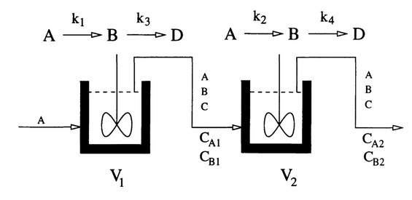

Problem Formulation –

Given data -

k1 = 0.09755988, k2 = 0.99*k1

k3 = 0.0391908, k4 = 0.9*k3

CA0 = 1

$$C_{A1}= \frac{1}{(1+k1*V1)} C_{A2}= \frac{C_{A1}}{(1+k2*V2)}$$

$$C_{B1}= \frac{(1-C_{A1})}{(1+k3*V1)} C_{B2}= \frac{(C_{B1}+C_{A1}-C_{A2})}{(1+k4*V2)}$$

Objective Function –

$$\min_{C_{A1}, C_{A2},C_{B1},V1,V2}{f= -C_{B2}= }-\left(\frac{{(C}_{B1}+C_{A1}-C_{A2})}{\left(1+k4*V2\right)}\right)$$

Constraints –

$${0≤C}_{A1},C_{A2},C_{B1},C_{B2}≤1$$

$${(V1}^{0.5}+{V2}^{0.5})≤4$$

$${10}^{-5}≤V1,V2≤16$$

Excel Solution –

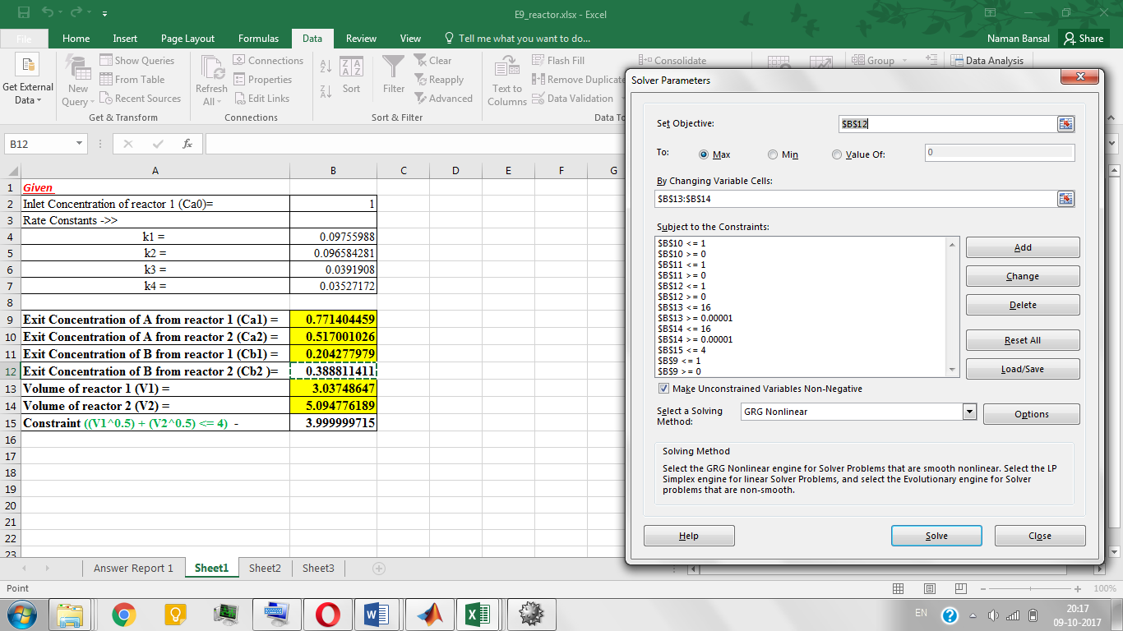

MATLAB Code –

% NLP Example  
% determine the volume of two reactors in series to maximize the concentration of B leaving from reactor 2  
% exit concentration of A and B and volume of both the reactors are variables  
% Reference pg 7 of the following document -  
% http://www.academia.edu/5332657/Efficient_constraint_handling_scheme_for_differential_evolutionary_algorithm_in_solving_chemical_engineering_optimization_problem  
  
function reactor()  
A = []; B = []; % Ax<=B  
Aeq = []; Beq = []; % Aeq=Beq  
  
lb = [0,0,0,0.00001,0.00001]; % lower bound  
ub = [1,1,1,16,16]; % upper bound  
x0 = [0,0,0,0,0];  
% x0 -> inital guess of concentration of A & B leaving both the reactors  
% and volumes of both reactor 1 and 2  
  
[x,fval,exitflag] = fmincon(@objfun,x0,A,B,Aeq,Beq,lb,ub,@confun);  
  
Ca1 = x(1); % concentration of A leaving from reactor 1  
Ca2 = x(2); % concentration of A leaving from reactor 2  
Cb1 = x(3); % concentration of B leaving from reactor 1  
V1 = x(4); % volume of reactor 1  
V2 = x(5); % volume of reactor 2  
Cb2 = -fval; % concentration of B leaving from reactor 2  
  
disp('concentration of A leaving from reactor 1 (Ca1) =');disp(Ca1);  
disp('concentration of A leaving from reactor 2 (Ca2) =');disp(Ca2);  
disp('concentration of B leaving from reactor 1 (Cb1) =');disp(Cb1);  
disp('maximum concentration of B leaving from reactor 2 (Cb2) =');disp(Cb2);  
disp('optimized volume of reactor 1 (V1) =');disp(V1);  
disp('optimized volume of rector 2 (V2) =');disp(V2);  
disp('exitflag =');disp(exitflag);  
  
function f = objfun(x)  
  
k1 = 0.09755988; % rate constant for reaction A -> B in reactor 1  
k2 = 0.99*k1; % rate constant for reaction A -> B in reactor 2  
k3 = 0.0391908; % rate constant for reaction B -> C in reactor 1  
k4 = 0.9*k3; % rate constant for reaction B -> C in reactor 2  
  
Ca1 = x(1); % concentration of A leaving from reactor 1  
Ca2 = x(2); % concentration of A leaving from reactor 2  
Cb1 = x(3); % concentration of B leaving from reactor 1  
V1 = x(4); % volume of reactor 1  
V2 = x(5); % volume of reactor 2  
  
Cb2 = ((Cb1-Ca2+Ca1)/(1+(k4*V2)));  
  
f= -Cb2; % concentration of B leaving from reactor 2  
  
function [C,Ceq] = confun(x)  
  
k1 = 0.09755988; % rate constant for reaction A -> B in reactor 1  
k2 = 0.99*k1; % rate constant for reaction A -> B in reactor 2  
k3 = 0.0391908; % rate constant for reaction B -> C in reactor 1  
k4 = 0.9*k3; % rate constant for reaction B -> C in reactor 2  
  
Ca1 = x(1); % concentration of A leaving from reactor 1  
Ca2 = x(2); % concentration of A leaving from reactor 2  
Cb1 = x(3); % concentration of B leaving from reactor 1  
V1 = x(4); % volume of reactor 1  
V2 = x(5); % volume of reactor 2  
  
C = -4+((x(4)^0.5)+(x(5)^0.5)); % C(x)<=0  
  
con1 = -1+((1+(k1*V1))*Ca1);  
con2 = -x(1)+(1+(k2*V2))*Ca2;  
con3 = -1+x(1)+(1+(k3*V1))*Cb1;  
  
Ceq = [con1,con2,con3]; % Ceq(x)=0

MATLAB Solution –

Concentration of A leaving from reactor 1 (Ca1) = 0.7715

Concentration of A leaving from reactor 2 (Ca2) = 0.5170

Concentration of B leaving from reactor 1 (Cb1) = 0.2042

Maximum concentration of B leaving from reactor 2 (Cb2) = 0.3888

Optimized volume of reactor 1 (V1) = 3.0356

Optimized volume of rector 2 (V2) = 5.0972

Exitflag = 1

Reference –

Page 7 from this [document](http://www.academia.edu/5332657/Efficient_constraint_handling_scheme_for_differential_evolutionary_algorithm_in_solving_chemical_engineering_optimization_problem)

**Example 10 –**

A plants produces refrigerators at the rate of P units per day. The variable costs per Refrigerator have been found to be $47.73 + 0.1*P1.2. The total daily fixed charges are $1750, and all other expenses are constant at $7325 per day. If the selling price per refrigerator is $173, determine the daily profit at a production schedule giving the minimum cost per refrigerator.

Problem Formulation –

$P-$ No. of refrigerator units produced per day

Daily Fixed Charges ($Fc$) = 1750

Daily other expenses ($Oe$) = 7325

Selling Price per refrigerator ($Ps$) = 173

Variable Cost per refrigerator ($Vc$) = $47.73 +(0.1*P^{1.2})$

Objective Function –

$$\min_{P}{f=\left(\frac{Fc+Oe}{P}\right)+Vc}$$

Variable Bounds –

$$P>0$$

Excel Solution –

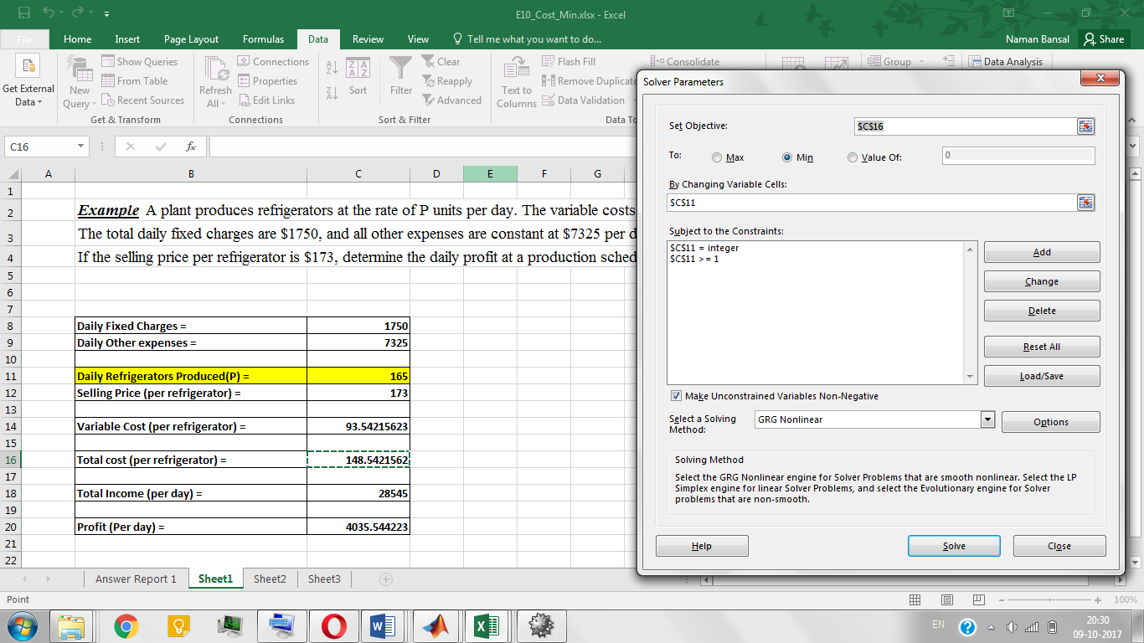

MATLAB Code –

% INLP example  
% Optimization of no of refrigerators unit produced giving minimum total cost  
% No of refrigerators produced is variable  
% Reference - pg 352, example 2 of following book MAX S. PETERS & KLAUS  
% D.TIMMERHAU. Plant Design and Economics for Chemical Engineers. 4th  
% edition  
  
function inl()  
A = -[1]; B = -[0]; % AX <= B  
Aeq = []; Beq = []; % AeqX = B  
lb = [1]; ub = [1000]; % lower bound and upper bound  
%x0 = [1]; % initial guess for no of refrigeartor unit produced  
  
% x - no of refrigerator unit produced  
% fval - total minimum cost for x refrigerator units  
nvrs=1;  
intcon=1;  
[x,fval,exitflag] = ga(@objfun,nvrs,[],[],[],[],lb,ub,@confun,intcon);  
  
%x = int16(x); % no of refrigerator unit must be integer  
tc = fval*x; % daily total cost  
Ps = 173; % selling price of refrigerator  
P = (Ps*x)-(tc);% daily total profit  
  
disp('no of refrigerators produced ='); disp(x);  
disp('daily total minimum cost ='); disp(tc);  
disp('daily profit ='); disp(P);  
disp('exitflag ='); disp(exitflag);  
  
function f = objfun(x)  
Fc = 1750; % daily fixed charges  
Oe = 7325; % daily other expences  
Vc = 47.73+(0.1*x^1.2); % variable cost  
  
% f - cost of one refrigerator unit  
f = ((Fc+Oe)/x)+Vc;  
  
function [C,Ceq] = confun(x)  
C = [];  
Ceq = [];

MATLAB Solution –

No. of refrigerators produced = 165

Daily total minimum cost = 2.4509e+04

Daily profit = 4.0355e+03

Exitflag = 1

Reference –

*MAX S. PETERS* & *KLAUS D.TIMMERHAU.* ***Plant Design and Economics for Chemical Engineers.*** 4th edition, pg 366, example 2

**Example 11 –**

A refinery has available two crude oils that have the yields shown in the following table. Because of equipment and storage limitations, productions of gasoline, kerosene, and fuel oil must be limited as also shown in this table. There are no plant limitations on the products such as gas oils.

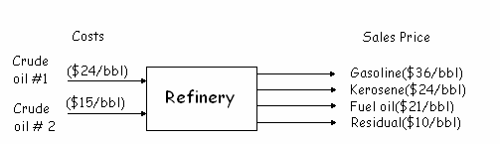

Find the approximate optimum daily feed rates of the two crudes to his plant for maximum profit.

|  |  |  |  |
| --- | --- | --- | --- |
| Product Name | Volume Percent | | Maximum allowable product rate(bbl/day) |
| Crude #1 | Crude #2 |
| Gasoline | 70 | 31 | 6,000 |
| Kerosene | 6 | 9 | 2,400 |
| Fuel Oil | 24 | 60 | 8,000 |

Problem Formulation –

$f1-$ flow rate of crude #1

$f2-$ flow rate of crude #2

$$Total income = amount produces (bbl/day) * sales price (\$/bbl)$$

$$Total cost = amount of crude fed (bbl/day) * cost of crude oil (\$/bbl)$$

Objective Function –

$$\max_{f1,f2}{f\left(total profit\right)=total income-total cost}$$

Constraints –

$$amount of gasoline ≤6000 bbl/day$$

$$amount of kerosene ≤2400 bbl/day$$

$$amount of fuel oil ≤8000 bbl/day$$

Variable Bounds –

$$f1,f2>0$$

Excel Solution –

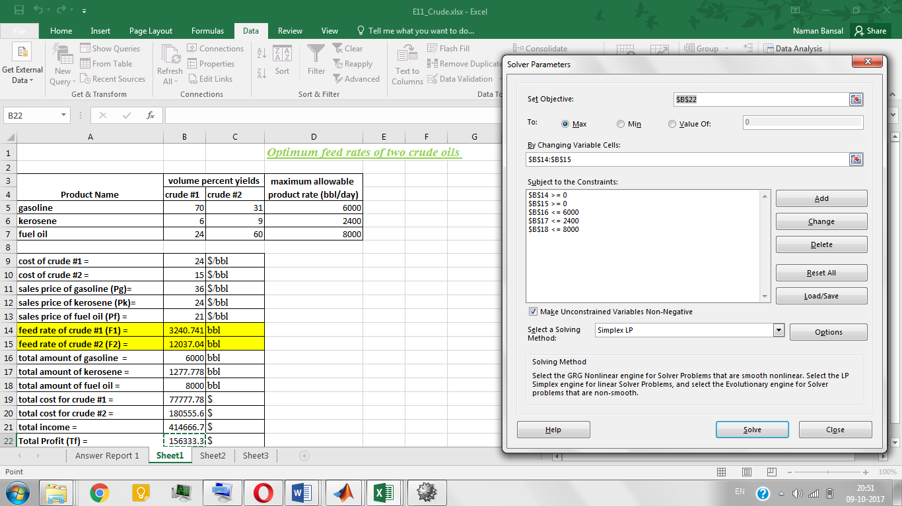

MATLAB Code –

% LP example  
% Optimization of feed flow rate two crude oils giving maximum profit  
% Flow rate of two crude oils are variable  
% Reference - pg 5 of following document - http://ukmk11.ogu.edu.tr/arsiv/ukmk6/sunu/PSM010.pdf  
  
function crude()  
A = [-1,0,0,0,0;  
 0,-1,0,0,0;  
 0,0,1,0,0;  
 0,0,0,1,0;  
 0,0,0,0,1];  
B = [0;0;6000;2400;8000]; % AX<=B  
  
Aeq = [0.70,0.31,-1,0,0;  
 0.06,0.09,0,-1,0;  
 0.24,0.60,0,0,-1];  
Beq = [0;0;0]; % AeqX = Beq  
  
lb = [0;0;0;0;0]; ub = [ ; ]; % lower and upper bound  
x0 = [0;0;0;0;0]; % initial guess of flow rates  
  
% f1 - flow rate of crude #1  
% f2 - flow rate of crude #2  
% Ag - total ammount of gasoline  
% Ak - total ammount of kerosene  
% Af - total ammount of fuel oil  
  
% x = [f1;f2;Ag;Ak;Af]  
% tp = total maximum profit  
  
[x,tp,exitflag] = fmincon(@objfun,x0,A,B,Aeq,Beq,lb,ub);  
  
f1 = x(1); % flow rate of crude #1 (bbl/day)  
f2 = x(2); % flow rate of crude #2 (bbl/day)  
  
disp('optimum flow rate of crude #1 (bbl/day) ='); disp(f1);  
disp('optimum flow rate of crude #2 (bbl/day) ='); disp(f2);  
disp('total maximum profit($) ='); disp(-tp);  
disp('exitflag ='); disp(exitflag);  
  
function f = objfun(x)  
cc1 = 24; % cost of crude#1 ($/bbl)  
cc2 = 15; % cost of crude#2 ($/bbl)  
Pg = 36; % sales price of gasoline ($/bbl)  
Pk = 24; % sales price of kerosene ($/bbl)  
Pf = 21; % sales price of fuel oil ($/bbl)  
f1 = x(1); % flow rate of crude #1 (bbl/day)  
f2 = x(2); % flow rate of crude #2 (bbl/day)  
Ag = x(3); % total ammount of gasoline (bbl/day)  
Ak = x(4); % total ammount of kerosene (bbl/day)  
Af = x(5); % total ammount of fuel oil (bbl/day)  
  
ti = (Ag*Pg)+(Ak*Pk)+(Af*Pf); % total income = amount(bbl/day)*sales price($/bbl)  
  
tc = (f1*cc1)+(f2*cc2);% total cost = amount of crude(bbl/day)*costof crude($/bbl)  
  
tp = (ti-tc); % tp - total profit  
f = -tp;

MATLAB Solution –

Optimum flow rate of crude #1 (bbl/day) = 3.2407e+03

Optimum flow rate of crude #2 (bbl/day) = 1.2037e+04

Total maximum profit ($) = 1.5633e+05

Exitflag = 1

Reference –

Page 5 of this [document](http://ukmk11.ogu.edu.tr/arsiv/ukmk6/sunu/PSM010.pdf)

**Example 12 –**

Feed to three units is split into three streams: FA, FB and FC. Two products are produces: P1 and P2 (see following figure), and the yield in weight percent by unit is

|  |  |  |  |
| --- | --- | --- | --- |
| Yield (weight %) | Unit A | Unit B | Unit C |
| P1 | 40 | 30 | 50 |
| P2 | 60 | 70 | 50 |

Each stream has values in $/lb as follows:

|  |  |  |  |
| --- | --- | --- | --- |
| Stream | F | P1 | P2 |
| Value ($/lb) | 0.40 | 0.60 | 0.50 |

Because of capacity limitations, certain constraints exist in the stream flows.

1. The total input feed must not exceed 10,000 lb/day.
2. The feed to each of the units A, B and C not exceed 5000 lb/day.
3. No more than 4000 lb/day of P1 can be used, and no more than $7000 lb/day of P2 can be used.

Determine the values of FA, FB and FC that maximize the daily profit.

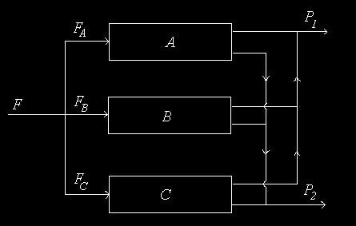

Problem Formulation –

$F_{A}-$ Feed to unit 1 $F_{B}-$ Feed to unit 2 $F_{C}-$ Feed to unit 3

$P1-$ Outlet flow product 1 $P2-$ Outlet flow product 2

$$Income = Income from product 1 + Income from product 2$$

Objective Function –

$$\max_{FA, FB, FC}{f(Daily Profit)}=Income-Cost of feed$$

Constraints –

$Input feed ≤10,000 lb/day$

$FA, FB, FC ≤5000 lb/day$

$P1 ≤4000 lb/day$

$P2 ≤7000 lb/day$

Excel Solution –

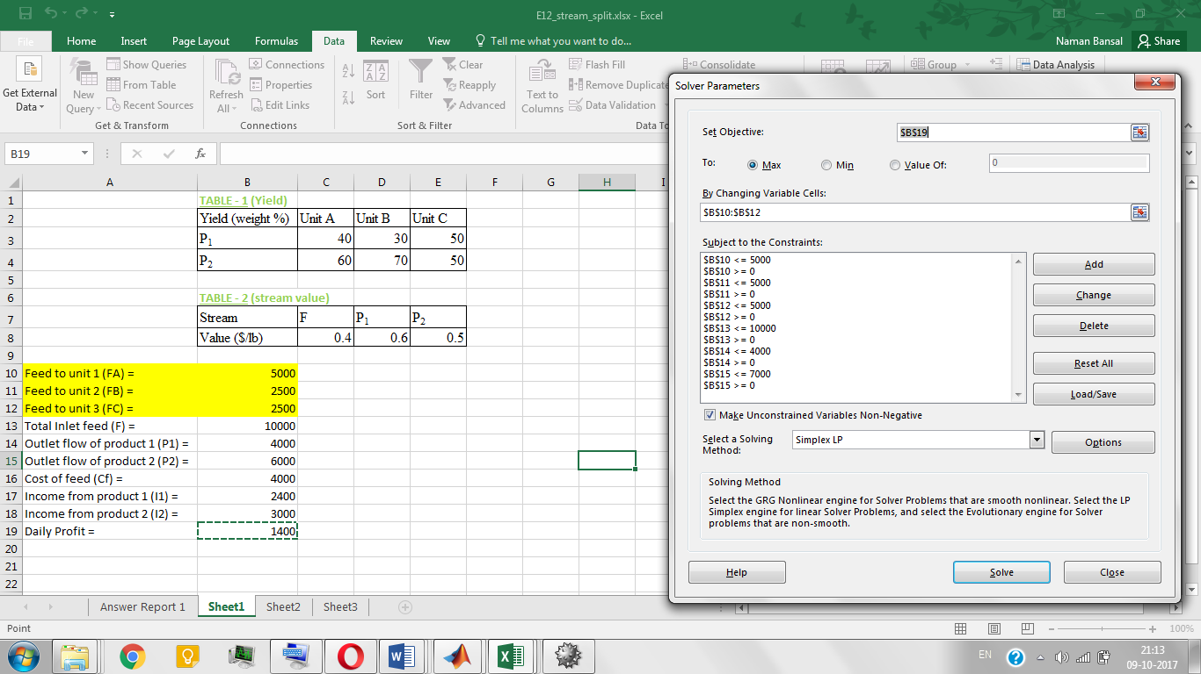

MATLAB Code –

% LP example  
% Optimization of feed flow rate to three reactor units giving maximum profit  
% Flow rate to three reactor units are variables  
% Reference - pg 6 of following document - http://ukmk11.ogu.edu.tr/arsiv/ukmk6/sunu/PSM010.pdf  
  
function stream_split()  
A = [1,0,0,0,0,0;  
 0,1,0,0,0,0;  
 0,0,1,0,0,0;  
 0,0,0,1,0,0;  
 0,0,0,0,1,0;  
 0,0,0,0,0,1];  
  
 B = [5000;5000;5000;10000;4000;7000]; % AX <= B  
  
Aeq = []; Beq = []; % AeqX = Beq  
lb = [0;0;0;0;0;0]; ub = [5000;5000;5000;10000;4000;7000]; % lower and upper bound  
x0 = [0;0;0;0;0;0]; % initial guess  
  
% x = [FA,FB,FC,F,P1,P2]  
% fval = daily profit  
  
[x,fval,exitflag] =fmincon(@objfun,x0,A,B,Aeq,Beq,lb,ub,@confun);  
  
FA = x(1); % inlet feed to unit1  
FB = x(2); % inlet feed to unit2  
FC = x(3); % inlet feed to unit3  
F = x(4); % total inlet feed  
P1 = x(5); % outlet flow of product1  
P2 = x(6); % outlet flow of product2  
  
disp('inlet feed to unit1 ='); disp(FA);  
disp('inlet feed to unit2 ='); disp(FB);  
disp('inlet feed to unit3 ='); disp(FC);  
disp('total inlet feed ='); disp(F);  
disp('outlet flow of product1 ='); disp(P1);  
disp('outlet flow of product2 ='); disp(P2);  
disp('maximum daily profit ='); disp(-fval);  
disp('exitflag ='); disp(exitflag);  
  
function f = objfun(x)  
F = x(4); % total inlet feed  
P1 = x(5); % outlet flow of product1  
P2 = x(6); % outlet flow of product2  
  
Cf = 0.4*F; % cost of feed  
I1 = 0.6*P1; % income from product 1  
I2 = 0.5*P2; % income from product 2  
  
f = -((I1+I2)-Cf);  
  
function [C,Ceq] = confun(x)  
FA = x(1); % inlet feed to unit1  
FB = x(2); % inlet feed to unit2  
FC = x(3); % inlet feed to unit3  
F = x(4); % total inlet feed  
P1 = x(5); % outlet flow of product1  
P2 = x(6); % outlet flow of product2  
  
C = []; % C(x)<+0  
  
con1 = -F+(FA+FB+FC);  
con2 = -P1+((0.4*FA)+(0.3*FB)+(0.5*FC));  
con3 = -P2+((0.6*FA)+(0.7*FB)+(0.5*FC));  
  
Ceq = [con1,con2,con3]; % Ceq(x)=0

MATLAB Solution –

Inlet feed to unit1 = 3.3164e+03

Inlet feed to unit2 = 3.3418e+03

Inlet feed to unit3 = 3.3418e+03

Total inlet feed = 1.0000e+04

Outlet flow of product1 = 4.0000e+03

Outlet flow of product2 = 6.0000e+03

Maximum daily profit = 1.4000e+03

Exitflag = 1

Reference –

Page 6 from this [document](http://ukmk11.ogu.edu.tr/arsiv/ukmk6/sunu/PSM010.pdf)

**Example 13 –**

Solve the following linear programming problem.

Objective Function –

$$\min{-x\left(1\right)-\frac{x\left(2\right)}{3}}$$

Constraints –

$$x\left(1\right)+x\left(2\right)≤2$$

$$x\left(1\right)+\frac{x\left(2\right)}{4}≤1$$

$$x\left(1\right)-x\left(2\right)≤2$$

$$-\frac{x\left(1\right)}{4}-x\left(2\right)≤2$$

$$-x\left(1\right)-x\left(2\right)≤-1$$

$$-x\left(1\right)+x\left(2\right)≤2$$

$$x\left(1\right)+\frac{x\left(2\right)}{4}=\frac{1}{2}$$

Variable Bounds –

$$-1≤x\left(1\right)≤1.5$$

$$-0.5≤x\left(2\right)≤1.25$$

Excel Solution –

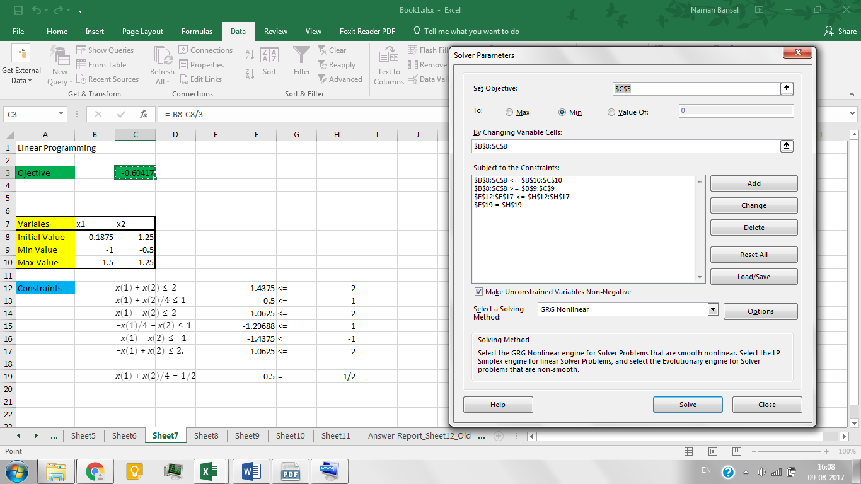

MATLAB Code –

% Linear Programming  
% Toy example 1  
  
% Ax <= b  
A = [1, 1; 1, 1/4; 1, -1; -1/4, -1; -1, -1; -1, 1];  
b = [2 1 2 1 -1 2];  
  
% Aeqx = beq  
Aeq = [1 1/4];  
beq = 1/2;  
  
% bounds on variables  
lb = [-1,-0.5];  
ub = [1.5,1.25];  
  
% objective function ( f.x )  
f = [-1 -1/3];  
  
options = optimoptions('linprog','Algorithm','interior-point');  
  
[x, fval, exitflag, output] = linprog(f,A,b,Aeq,beq,lb,ub, options);

MATLAB Solution –

$$x={\left[0.1875, 1.2500\right]}^{T}$$

$$fval=-0.6042$$

$$exitflag=1$$

Reference –

<https://in.mathworks.com/help/optim/ug/linprog.html> (Example 1)

**Example 14** **–**

Solve the following quadratic programming problem.

Objective Function –

$$\min_{x}{f\left(x\right)=c^{T}x}{- 0.5x^{T}Qx}$$

Data –

$$c=(42, 44, 45, 47, 47.5)^{T}$$

$$Q=100I$$

where $I$ is the identity matrix.

Constraints –

$$20x\left(1\right)+12x\left(2\right)+11x\left(3\right)+7x\left(4\right)+4x(5)≤40$$

Variable Bounds –

$$0≤x≤1$$

Non-Convex Problem –

$$\frac{∂f(x)}{∂x}=c^{T}-100x^{T}$$

$$\frac{∂^{2}f(x)}{∂x^{2}}=-100I$$

Since the second derivative of the objective function in negative definite matrix, it is a non-convex problem.

Excel Solution –

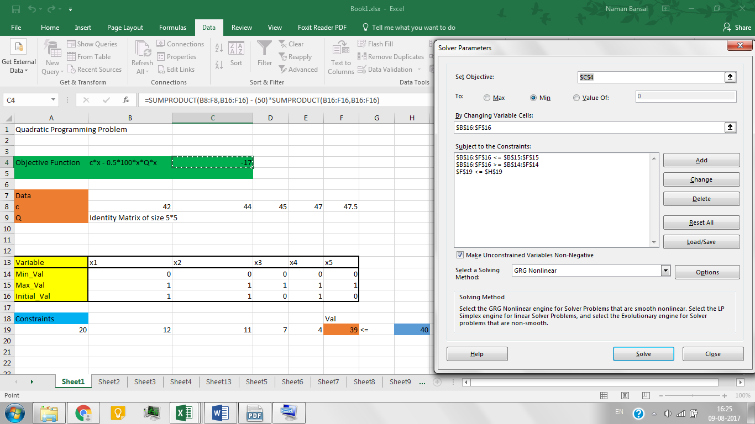

MATLAB Code –

* Matlab’s ‘quadprog’ function can’t solve this problem due to the non-convexity of the problem.
* Also, ‘fmincon’ is not suitable for this problem as it tends to converge to local optimum.

We use genetic algorithm to solve this problem as it generates an initial population of size 50 to find the optimum value. Therefore, we can get global optimum after several run of the program.

% Quadratic Programming  
% Toy problem 1  
  
fun = @prac_fun;  
  
% Ax <= b  
A = [20, 12, 11, 7, 4];  
b = 40;  
  
% Aeqx = beq  
Aeq = [];  
beq = [];  
  
% bounds on the variables  
lb = zeros(5, 1);  
ub = ones(5, 1);  
  
  
options = optimoptions('ga', 'Display','off');   
  
disp('Working')  
  
[x, fval, exitflag, output, population ] = ga(fun, 5, A, b, Aeq, beq, lb, ub, [], options);

% Objective Function  
function [fval] = prac_fun(x)  
 H = 100*speye(5);  
 f = [42, 44, 45, 47, 47.5];  
 fval = f*x' - 0.5*x*H*x';  
end

MATLAB Solution –

We report the minimum value of the objective function based on the several run of the program.

|  |  |  |
| --- | --- | --- |
| Run Number | Minimum Function Value | Independent Variables |
| 1 | -10.9974 | $${\left[0.0000, 1.0000, 1.0000, 0.0000, 0.0000\right]}^{T}$$ |
| 2 | -13.4997 | $${\left[1.0000, 0.0000, 0.0000, 1.0000, 1.0000\right]}^{T}$$ |
| 3 | -13.5 | $${\left[1, 0, 0, 1, 1\right]}^{T}$$ |
| 4 | -15.9999 | $${\left[1.0000, 0.0000, 1.0000, 1.0000, 0.0000\right]}^{T}$$ |
| 5 | -10.4999 | $${\left[0.0000, 0. 0000, 1. 0000, 1. 0000, 1. 0000\right]}^{T}$$ |
| 6 | -13.9579 | $${\left[0.0000, 1.0000, 1.0000, 1. 0000, 0.0009\right]}^{T}$$ |
| 7 | -17 | $${\left[1, 1, 0, 1, 0\right]}^{T}$$ |
| 8 | -16.9998 | $${\left[1.0000, 1. 0000, 0. 0000, 1. 0000, 0. 0000\right]}^{T}$$ |
| 9 | -16 | $${\left[1, 0, 1, 1, 0\right]}^{T}$$ |
| 10 | -15.4999 | $${\left[1.0000, 0. 0000, 1. 0000, 0. 0000, 1. 0000\right]}^{T}$$ |

Final Solution:

$$x={\left[1, 1, 0, 1, 0\right]}^{T}$$

$$fval=-17$$

$$exitflag=1$$

Reference –

Floudas, Christodoulos A., et al. *Handbook of test problems in local and global optimization*. Vol. 33. Springer Science & Business Media, 2013.

(Chapter 2, Section 2.2, Test Problem 1)

**Example 15** **–**

Solve the following quadratic programming problem.

Objective Function –

$$\min_{x, y}{f\left(x\right)=c^{T}x}{- 0.5x^{T}Qx+dy}$$

Data –

$$c=(-10.5, -7.5,-3.5,-2.5,-1.5)^{T}$$

$$d=-10$$

$$Q=100I$$

where $I$ is the identity matrix.

Constraints –

$$6x\left(1\right)+3x\left(2\right)+3x\left(3\right)+2x\left(4\right)+x(5)≤6.5$$

$$10x\left(1\right)+10x\left(3\right)+y≤20$$

Variable Bounds –

$$0≤x≤1$$

$$0≤y$$

Excel Solution –



MATLAB Code –

* Matlab’s ‘*quadprog*’ function can’t solve this problem due to the non-convexity of the problem.
* Also, ‘*fmincon*’ is not suitable for this problem as it tends to converge to local optimum.

We use genetic algorithm to solve this problem as it generates an initial population of size 50 to find the optimum value. Therefore, we can get global optimum after several run of the program.

% Quadratic Programming  
% Toy problem 2  
  
fun = @fun2;  
  
% Ax <= b  
A = [6, 3, 3, 2, 1, 0; 10, 0, 10, 0, 0, 1];  
b = [6.5; 20];  
  
% Aeqx <= beq  
Aeq = [];  
beq = [];  
  
% bounds on variables  
lb = zeros(6, 1);  
ub = ones(6, 1);  
ub(6, 1) = Inf;  
  
options = optimoptions('ga', 'Display', 'off', ‘PopulationSize’, 50);  
  
[x, fval, exitflag, output, population ] = ga(fun, 6, A, b, Aeq, beq, lb, ub, [], options);

% objective function  
function [fval] = fun2(x)  
c = [-10.5, -7.5, -3.5, -2.5, -1.5]';  
d = -10;  
Q = 100*speye(5);  
fval = x(1:5)*c - 0.5*x(1:5)*Q*x(1:5)' + d*x(6);  
end

MATLAB Solution –

We report the minimum value of the objective function based on the several run of the program.

|  |  |  |
| --- | --- | --- |
| Run Number | Minimum Function Value | Independent Variables  (x1, x2, x3, x4, x5, y) |
| 1 | -355.6933 | $${\left[0.0549, 0.9989, 0.0084, 0.9999, 0.9989, 19.3668\right]}^{T}$$ |
| 2 | -346.3864 | $${\left[0.0489 0.9951 0.0575 0.9820 0.9710 18.9140\right]}^{T}$$ |
| 3 | -359.5022 |  |
| 4[1]* | -361.5009 | ${\left[0.0001 1.0000 0.0000 1.0000 1.0000 20.0000\right]}^{T}$ |
| 5 | -357.6756 | $${\left[0.0259 0.9932 0.0039 0.9989 0.9990 19.6800\right]}^{T}$$ |
| 6 | -361.5 | $${\left[0, 1, 0, 1, 1, 20\right]}^{T}$$ |
| 7 | -351.8141 | $${\left[0.0011 1.0000 0.1052 1.0000 1.0000 18.9381\right]}^{T}$$ |
| 8 | -361.4518 | $${\left[0.0003 1.0000 0.0003 1.0000 1.0000 19.9948\right]}^{T}$$ |
| 9 | -355.1671 | $${\left[0.0719 1.0000 0.0017 1.0000 1.0000 19.2647\right]}^{T}$$ |
| 10 | -349.5474 | $${\left[0.0097 0.9998 0.1194 0.9993 0.9998 18.6918\right]}^{T}$$ |

Final Solution:

$$[x, y]={\left[0, 1, 0, 1, 1, 20\right]}^{T}$$

$$fval=-361.5$$

$$exitflag=1$$

Reference –

Floudas, Christodoulos A., et al. *Handbook of test problems in local and global optimization*. Vol. 33. Springer Science & Business Media, 2013.

(Chapter 2, Section 2.3, Test Problem 2)

**Example 16** **–**

Solve the following NLP (quadratically constrained) problem.

Objective Function –

$$\min{x_{1}+{x_{2}+x_{3}}}$$

Constraints –

$$-1+0.0025(x_{4}+x_{6})≤0$$

$$-1+0.0025(-x_{4}+x_{5}+x_{6})≤0$$

$$-1+0.0025(-x_{5}+x_{8})≤0$$

$$100x_{1}-x_{1}x_{6}+8333.33252x_{4}-83333.333≤0$$

$$x_{2}x_{4}-x_{2}x_{7}-1250x_{4}+1250x_{5}≤0$$

$$x_{3}x_{5}-x_{3}x_{8}-2500x_{5}+1250000≤0$$

Variable Bounds –

$$100≤x_{1}≤10000$$

$$1000≤x_{2}≤10000$$

$$1000≤x_{3}≤10000$$

$$10≤x_{4}≤10000$$

$$10≤x_{5}≤1000$$

$$10≤x_{6}≤1000$$

$$10≤x_{7}≤1000$$

$$10≤x_{8}≤1000$$

Excel Solution –

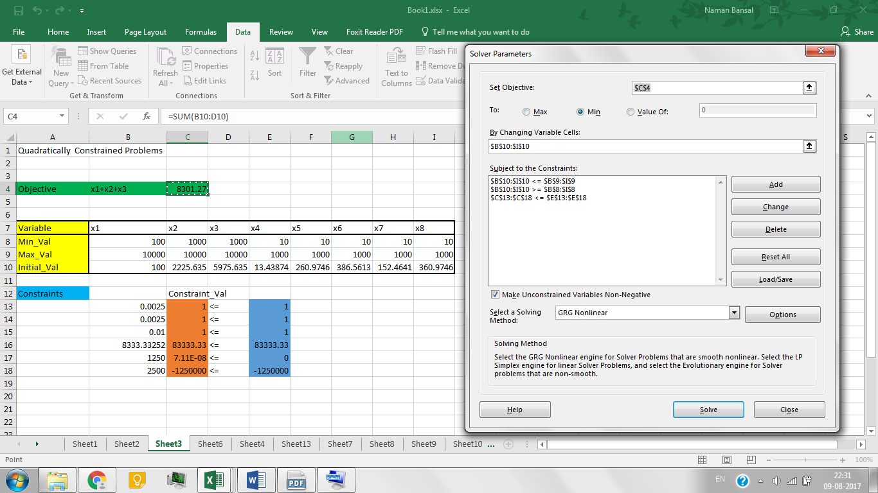

MATLAB Code –

We use ‘*fmincon*’ to solve this problem with 200 random initialization.

% Non-Linear Programming (Quadratically Constrainted Problems)  
% Toy Problem 1  
  
%fun = @chap3_fun1;  
fun = @(x) sum(x(1:3));  
  
% Non-linear constraints  
nonlcon = @chap3_nonlcon1;  
  
% Ax <= b  
A = [];  
b = [];  
  
% Aeqx <= beq  
Aeq = [];  
beq = [];  
  
% bounds on variables  
lb = [100; 1000; 1000; 10; 10; 10; 10; 10];  
ub = 1000*ones(8, 1);  
ub(1:3, 1) = 10*ub(1:3, 1);  
  
% One of the initial values of the variables apart from 200 other values  
x0 = ub;  
  
options = optimoptions('fmincon',...  
 'Algorithm','interior-point','Display','off', 'GradObj', 'off');  
  
problem = createOptimProblem('fmincon', 'x0', x0, 'objective', fun, ...  
 'lb', lb, 'ub', ub, 'nonlcon', nonlcon);  
ms = MultiStart;  
[out.x, out.fval, out.exitflag, out.output, out.solutions] = run(ms, problem, 200);  
  
out

% Non-Linear Constraints  
function [c, ceq] = chap3_nonlcon1(x)  
  
c = [ ( -1 + 0.0025*( x(4) + x(6) ) );...  
 ( -1 + 0.0025*( -x(4) + x(5) + x(7) ) );...  
 ( -1 + 0.01*( -x(5) + x(8) ) );...  
 ( 100*x(1) - x(1)*x(6) + 8333.33252*x(4) - 83333.333 );...  
 ( x(2)*x(4) - x(2)*x(7) - 1250*x(4) + 1250*x(5) );...  
 ( x(3)*( x(5) - x(8) ) -2500*x(5) + 1250000 ) ];  
ceq = [];  
  
end

MATLAB Solution –

$$x={1.0e+03*\left[0.1000, 2.2256, 5.9756, 0.0134, 0.2610, 0.3866, 0.1525, 0.3610\right]}^{T}$$

$$fval=8301.2702$$

$$exitflag=2$$

Reference –

Floudas, Christodoulos A., et al. *Handbook of test problems in local and global optimization*. Vol. 33. Springer Science & Business Media, 2013.

(Chapter 3, Section 3.2, Test Problem 1)

**Example 17** **–**

Solve the following integer linear programming (ILP) problem.

Objective Function –

$$\max{8x_{1}+{11x_{2}+6x_{3}+4x_{4}}}$$

Constraints –

$5x_{1}+7x_{2}+4x_{3}+3x_{4}≤14$

$x_{1}+x_{2}+x_{3}+x_{4}≤2$

$x_{2}-x_{4}≤0$

$x_{1}+x_{3}≤1$

Variable Bounds –

$$x_{j}∈\left\{0, 1\right\} j= 1, …4$$

$$0≤y$$

Excel Solution –

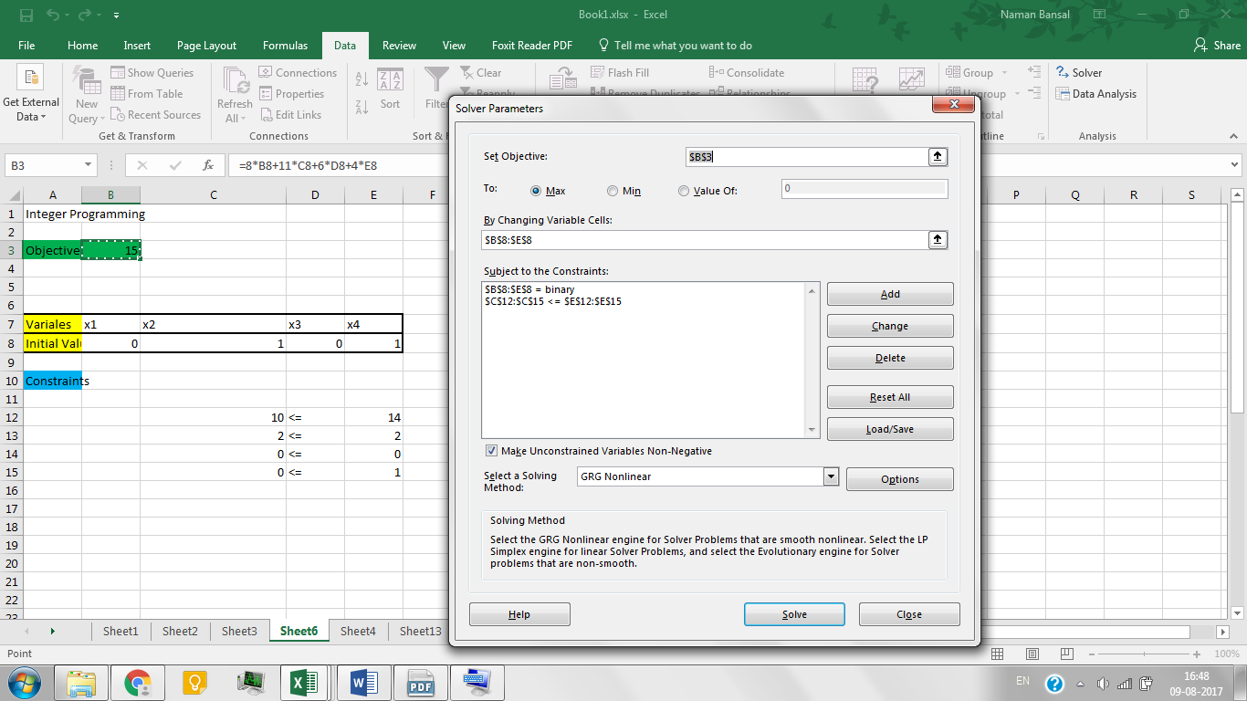

MATLAB Code –

% Integer Linear Programming  
% Toy Problem 1  
  
% Ax <= b  
A = [ 5, 7, 4, 3;  
 1, 1, 1, 1;  
 0, 1, 0, -1;  
 1, 0, 1, 0 ];  
b = [ 14; 2; 0; 1 ];  
  
% Aeqx <= beq  
Aeq = [];  
beq = [];  
  
% bounds on variables  
lb = [0 0 0 0];  
ub = [1 1 1 1];  
  
% integer constraints (variables listed in intcon takes integral values)  
intcon = [1 2 3 4];  
  
% Objective Function (f'x)  
f = [-8; -11; -6; -4]; % Because we have to maximize the objective function  
  
options = optimoptions('intlinprog','Display','off');  
  
[x, fval, exitflag, output] = intlinprog(f, intcon, A, b, Aeq, beq, lb, ub, options);

MATLAB Solution –

$$x={\left[0, 1, 0, 1\right]}^{T}$$

$$fval=15$$

$$exitflag=1$$

Reference –

Section 2.1 from this [document](http://www.math.clemson.edu/~mjs/courses/mthsc.440/integer.pdf)

**Example 18 –**

Solve the following integer non-linear programming (INLP) problem.

Objective Function –

$$\min_{y}{7y_{1}+10y_{2}}$$

Constraints –

$y_{1}^{1.2}y_{2}^{1.7}-7y_{1}-9y_{2}≤24$

${-y}_{1}-{2y}_{2}≤5$

${-3y}_{1}+y_{2}≤1$

$4y_{1}-3y_{2}≤11$

Variable Bounds –

$$y_{1}, y_{2}∈[1, 5]∩N$$

Excel Solution –

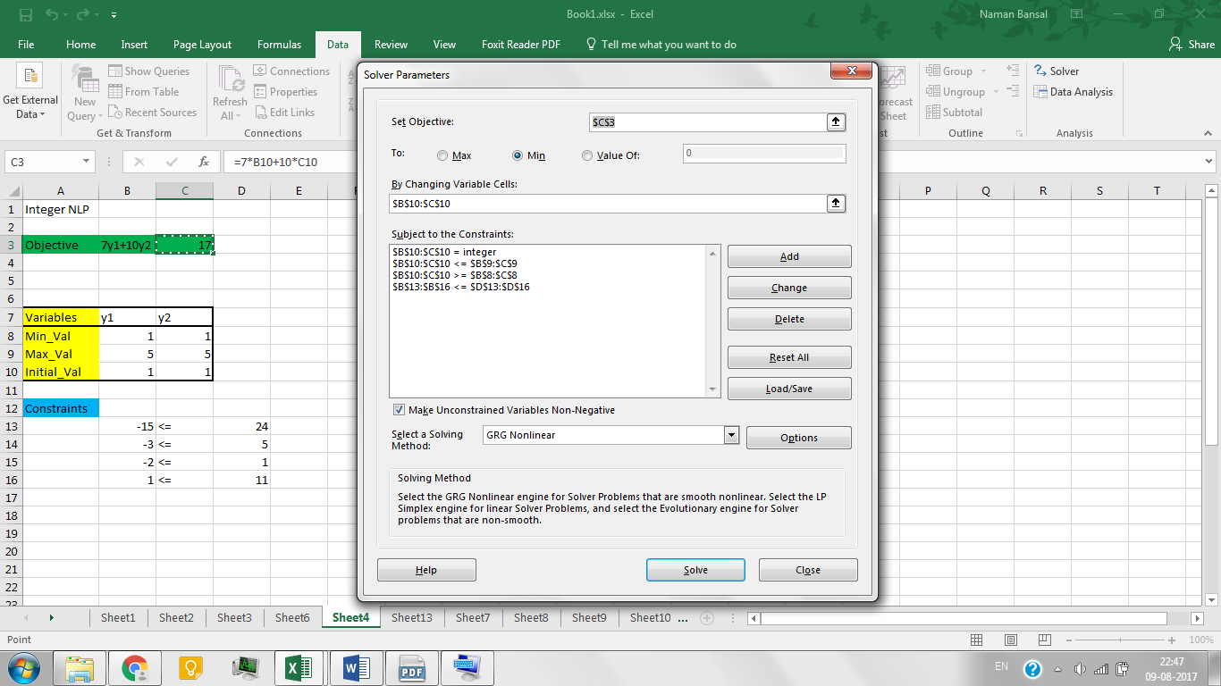

MATLAB Code –

% Integer Non-linear Programming  
% Toy Problem  
  
% Objective function  
fun = @(x) (7*x(1) + 10*x(2));  
  
% Non-linear Constraints  
nonlcon = @INLP_nonlcon;  
  
nvars = 2;  
  
% Ax <= b  
A = [];  
b = [];  
  
% Aeqx <= beq  
Aeq = [];  
beq = [];  
  
% bounds on variables  
lb = [1; 1];  
ub = [5; 5];  
  
% integer constraints (variables listed in intcon takes integral values)  
IntCon = [1, 2];  
  
% Initital value of variables  
x0 = lb;  
  
options = optimoptions(@ga,'MutationFcn',@mutationadaptfeasible);  
[out.x, out.fval, out.exitflag, out.OutputStruct] = ga(fun, nvars, ...  
 [], [], [], [], lb, ub, nonlcon, IntCon, options );  
  
out

% Non-Linear Constraints  
function [c, ceq] = INLP_nonlcon(x)  
  
c = [ ( (x(1)^1.2)*(x(2)^1.7) -7*x(1) -9*x(2) -24 );...  
 ( -x(1) - 2*x(2) -5 );...  
 ( -3*x(1) + x(2) - 1);...  
 ( 4*x(1) - 3*x(2) - 11 ) ];  
ceq = [];  
  
end

MATLAB Solution –

$$x={\left[1, 1\right]}^{T}$$

$$fval=17$$

$$exitflag=1$$

Reference –

Floudas, Christodoulos A., et al. *Handbook of test problems in local and global optimization*. Vol. 33. Springer Science & Business Media, 2013.

(Chapter 12, Section 12.2.5, Test Problem 5)

**Example 19** **–**

Solve the following INLP (Quadratic Integer Programming) problem.

Objective Function –

$$\min_{x}{c^{T}x+0.5x^{T}Qx}$$

Data –

$$c=(6, 8, 4, -2)^{T}$$

$$Q=\left[\begin{matrix} -1 & 2 & 0 & 0 \\ 2 & -1 & 2 & 0 \\ 0 & 2 & -1 & 2 \\ 0 & 0 & 2 & -1 \end{matrix}\right]$$

Constraints –

$$-1≤x_{1}x_{2}+x_{3}x_{4}≤1$$

$$-3≤x_{1}+x_{2}+x_{3}+x_{4}≤2$$

Variable Bounds –

$$x∈{\left\{-1, 1\right\}}^{4}$$

Excel Solution –

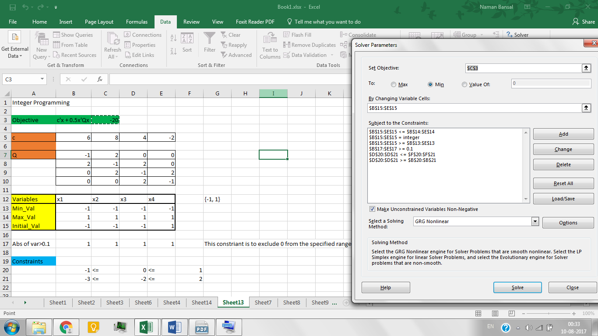

MATLAB Code –

% Integer Non-Linear Programming (Quadratic Integer Programming)  
% Toy problem  
  
%ga takes x as row vector  
c = [6, 8, 4, -2];  
Q = [-1, 2, 0, 0;  
 2, -1, 2, 0;  
 0, 2, -1, 2;  
 0, 0, 2, -1];  
  
% Objective Function  
fun = @(x) ( c*x' + x*Q*x' );  
  
% Non-linear Constraints  
nonlcon = @INLP_nonlcon1;  
  
nvars = 4;  
  
% Ax <= b  
A = [];  
b = [];  
  
% Aeqx <= beq  
Aeq = [];  
beq = [];  
  
% bounds on variables  
lb = [-1; -1; -1; -1];  
ub = [1; 1; 1; 1];  
  
% integer constraints (variables listed in intcon takes integral values)  
IntCon = [1, 2, 3, 4];  
  
% Initial value of variables  
x0 = lb;  
  
options = optimoptions(@ga,'MutationFcn',@mutationadaptfeasible);  
[out.x, out.fval, out.exitflag] = ga(fun, nvars, [], [], [], [], ...  
 lb, ub, nonlcon, IntCon, options );  
  
out

% Non-linear constraints  
function [c, ceq] = INLP_nonlcon1(x)  
  
c = [ ( x(1)*x(2) + x(3)*x(4) -1 );...  
 ( -x(1)*x(2) - x(3)*x(4) -1 );...  
 ( sum(x) - 2 );...  
 ( -sum(x) - 3 );...  
  
 % this is to make sure that 0 is not a feasible point  
 ( -norm(x, 1) + 0.1 )];  
  
ceq = [];  
  
end

MATLAB Solution –

$$x={\left[-1, -1, -1, -1\right]}^{T}$$

$$fval=-20$$

$$exitflag=1$$

Reference –

Floudas, Christodoulos A., et al. *Handbook of test problems in local and global optimization*. Vol. 33. Springer Science & Business Media, 2013.

(Chapter 13, Section 13.2.1, Quadratic 0-1 Test problems)

**Example 20** **–**

Solve the following MINLP problem.

Objective Function –

$$\min_{x, y}{3y-5x}$$

Constraints –

$$2y^{2}-2y^{0.5}-2x^{0.5}y^{2}+11y+8x≤39$$

$$-y+x≤3$$

$$2y+3x≤24$$

Variable Bounds –

$$1≤x≤10$$

$$y∈[1, 6]∩N$$

Excel Solution –

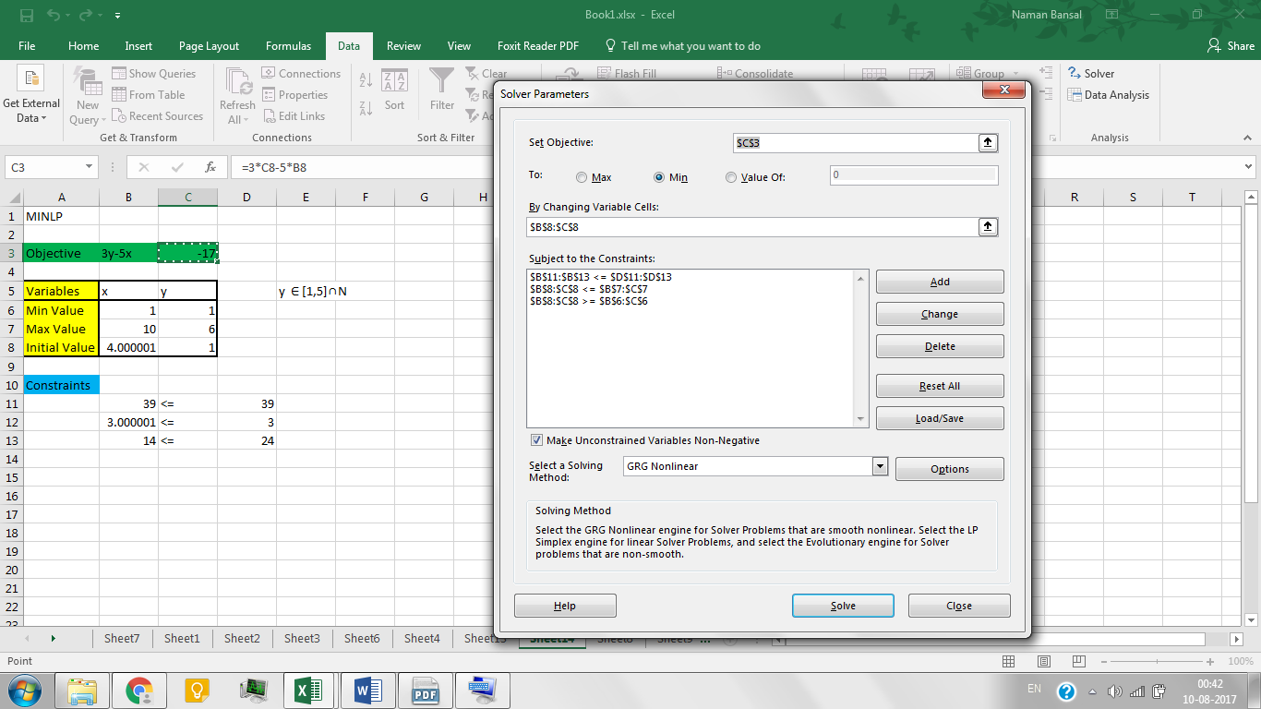

MATLAB Code –

% Mixed Integer Non-Linear Programming  
% Toy Problem 1  
  
% Objective Function (f'x)  
fun = @(x) ( 3*x(1) - 5*x(2) );  
  
% non-linear constraints  
nonlcon = @MINLP_nonlcon;  
  
nvars = 2;  
  
% Ax <= b  
A = [];  
b = [];  
  
% Aeqx <= beq  
Aeq = [];  
beq = [];  
  
% bounds on variables  
lb = [1; 1];  
ub = [6; 10];  
  
% integer constraints (variables listed in intcon takes integral values)  
IntCon = [1];  
  
% initial value of variables  
x0 = lb;  
  
options = optimoptions(@ga,'MutationFcn',@mutationadaptfeasible);  
[out.x, out.fval, out.exitflag] = ga(fun, nvars, [], [], [], [], ...  
 lb, ub, nonlcon, IntCon, options );

% non-linear constraints  
function [c, ceq] = MINLP_nonlcon(x)  
  
c = [ ( 2*x(1)^2 - 2*x(1)^0.5 - 2*(x(2)^0.5)*x(1)^2 + 11*x(1) + 8*x(2) - 39 );...  
 ( -x(1) + x(2) - 3 );...  
 ( 2*x(1) +3*x(2) - 24 )];  
ceq = [];  
  
end

MATLAB Solution –

$$x=4.0001, y=1$$

$$fval=-17$$

$$exitflag=1$$

Reference –

Floudas, Christodoulos A., et al. *Handbook of test problems in local and global optimization*. Vol. 33. Springer Science & Business Media, 2013.

(Chapter 12, Section 12.2.6, Test Problem 6)

**Example 21** –

Following is an example of very famous linear regression problem which under the category of quadratic programming problems. For the problem, we use ‘accidents’ dataset which contains data for fatal traffic accidents in U.S. states. Here we assume that there is a linear relation between total population of a state and the number of accidents.

Objective Function –

$$\min_{m, b}{\frac{1}{2n}\sum_{i=1}^{n}{{\left(mx_{i}+b-y_{i}\right)}^{2}}}$$

where $n$ is the number of data points.

Excel Solution –



MATLAB Code –

% Quadratic programming problem  
% Linear Regression  
  
% Dataset  
load accidents  
x = hwydata(:,14); %Population of states  
Y = hwydata(:,4); %Accidents per state  
  
X = [ones(length(Y), 1), x];  
  
% linear least-square problem  
[theta,resnorm,residual,exitflag] = lsqlin( X, Y, [], []);  
  
% Visualize the regression by plotting the actual values Y and the calculated values yCalc  
yCalc = X*theta;  
scatter(x,Y)  
hold on  
plot(x,yCalc)  
xlabel('Population of state')  
ylabel('Fatal traffic accidents per state')  
title('Linear Regression Relation Between Accidents & Population')  
grid on

MATLAB Solution –



Reference –

<http://in.mathworks.com/help/matlab/data_analysis/linear-regression.html>

**Example 22** –

Following is a portfolio optimization problem which comes under the category of quadratic programming problems.

Suppose that there are $n$ different assets. The rate of return of asset $i$ is a random variable with expected value $m_{i}$. The problem is to find what fraction $x_{i}$ to invest in each asset $i$ in order to minimize risk, subject to specified minimum expected rate of return.

We solve this problem for 100 assets out of 225 (due to limit of number of variables in excel) as provided in the dataset on OR-library.

Problem Formulation –

I. Let $C$ denote the covariance matrix of rates of asset returns. Then the classical mean-variance model consists of minimizing portfolio risk.

Objective Function –

$$\min_{x}{\frac{1}{2}x^{T}Cx}$$

Constraints –

The expected return should be no less than a minimal rate of portfolio return $r$ that the investor desires.

$$\sum_{i=1}^{n}{m_{i}x_{i}≥r}$$

where $n$ is 225 for this example.

The sum of the investment fractions $x_{i}$’s should add up to a total of one.

$$\sum_{i=1}^{n}{x_{i}=1}$$

Variable Bounds –

Also, being fractions (or percentages), $x_{i}$’s should e numbers between zero and one.

$$0≤x_{i}≤1, i=1…n.$$

II. We now add to the model group constraints that require that 30% of the investor's money has to be invested in assets 1 to 75, 30% in assets 76 to 150, and 30% in assets 151 to 225. Each of these groups of assets could be, for instance, different industries such as technology, automotive, and pharmaceutical. The constraints that capture this new requirement are

$$\sum_{i=1}^{75}{x_{i}=1, } \sum_{i=76}^{150}{x_{i}=1, } \sum_{i=151}^{225}{x_{i}=1}$$

Excel Solution –

By default, Excel Solver is able to solve for 100 variables. Therefore, we only consider first 100 assets in our running example.

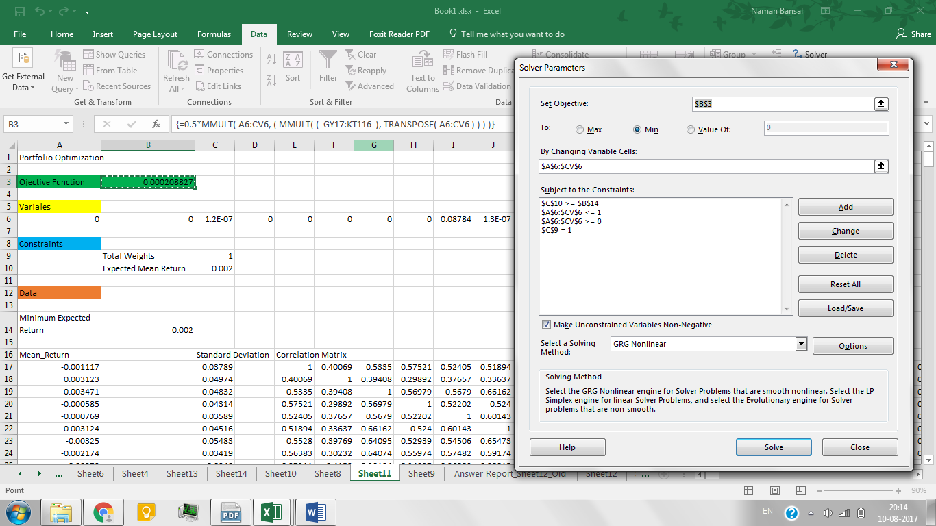

MATLAB Code –

We leverage the flexibility provided by Matlab to solve for all of the 225 assets.

% Quadratic Programming Problem  
% Portfolio Optimization  
  
% load the dataset  
load('port5.mat','Correlation','stdDev_return','mean_return')  
  
% Calculate covariance matrix from correlation matrix  
Covariance = Correlation .* (stdDev_return * stdDev_return');  
  
nAssets = numel(mean_return); r = 0.002; % number of assets and desired return  
  
Aeq = ones(1,nAssets); beq = 1; % equality Aeq*x = beq  
Aineq = -mean_return'; bineq = -r; % inequality Aineq*x <= bineq  
lb = zeros(nAssets,1); ub = ones(nAssets,1); % bounds lb <= x <= ub  
c = zeros(nAssets,1); % objective has no linear term; set it to zero  
  
options = optimoptions('quadprog', 'Algorithm', 'interior-point-convex');  
options = optimoptions(options, 'TolFun', 1e-10);  
[x1, fval1, exitflag1] = quadprog(Covariance, c, Aineq, bineq, ...  
 Aeq, beq, lb, ub, [], options);  
  
% plot results  
plotPortfDemoStandardModel(x1)  
  
% Add group constraints to existing equalities  
Groups = blkdiag(ones(1,nAssets/3), ones(1,nAssets/3), ones(1,nAssets/3));  
Aineq = [Aineq; -Groups]; % convert to <= constraint  
bineq = [bineq; -0.3*ones(3,1)]; % by changing signs  
  
[x2, fval2, exitflag2] = quadprog(Covariance, c, Aineq, bineq, ...  
 Aeq, beq, lb, ub, [], options);  
  
% Plot results, superimposed on results from previous problem.  
plotPortfDemoGroupModel(x1,x2);

function plotPortfDemoStandardModel(x1)  
% Copyright 2010 The Mathworks, Inc.  
  
figure;  
bar1 = bar(x1,'FaceColor','b','EdgeColor','b');  
set(bar1,'BarWidth',2);  
set(gca,'xlim',[1 ( length(x1)+5 )])  
set(gca,'ylim',[0 0.3])  
set(gca,'xTick',[1 75 150 225]);  
title('Standard model - 225-asset problem', 'FontName', 'Cambria', 'FontSize', 12)  
xlabel('Assets', 'FontName', 'Cambria')  
ylabel('Fraction of investment', 'FontName', 'Cambria')  
grid on  
  
end

function plotPortfDemoGroupModel(x1,x2)  
% Copyright 2010 The Mathworks, Inc.   
  
% Create figure  
figure2 = figure;  
  
% Create axes  
axes1 = axes('Parent',figure2,'XTick',[1 75 150 225]);  
xlim(axes1,[1 230]);  
ylim(axes1,[0 0.3]);  
box(axes1,'on');  
grid(axes1,'on');  
hold(axes1,'all');  
  
% Plot bars (standard model); increase width a little so that bars can be  
% seen behind the group model's bars  
bar(x1,'FaceColor',[0 0 1],'EdgeColor',[0 0 1],'BarWidth',2.5,...  
 'Parent',axes1,...  
 'DisplayName','Standard');  
  
% Plot bars (model with group constraints)  
idx = find(x2>.00001); % don't plot negligiblely small elements of solution  
bar(idx,x2(idx),'FaceColor',[1 0 0],'EdgeColor',[1 0 0],'BarWidth',1.5,...  
 'Parent',axes1,...  
 'DisplayName','With group constraints');  
  
% Create xlabel  
xlabel('Assets', 'FontName', 'Cambria' );  
% Create ylabel  
ylabel('Fraction of investment', 'FontName', 'Cambria');  
% Create title  
title('225-asset problem', 'FontName', 'Cambria', 'FontSize', 12)  
  
% Create legend  
legend1 = legend(axes1,'show');  
set(legend1,...  
 'Position',[0.454285714285709 0.714285714285715 0.417857142857143 0.1]);  
  
% Create textbox  
annotation(figure2,'textbox',...  
 [0.195642857142857 0.863920537540176 0.107928571428571 0.0595238095238109],...  
 'String',{'Group 1'},...  
 'HorizontalAlignment','center',...  
 'FitBoxToText','off',...  
 'LineStyle','none');  
  
% Create textbox  
annotation(figure2,'textbox',...  
 [0.465642857142857 0.863920537540176 0.107928571428571 0.0595238095238109],...  
 'String',{'Group 2'},...  
 'HorizontalAlignment','center',...  
 'FitBoxToText','off',...  
 'LineStyle','none');  
  
% Create textbox  
annotation(figure2,'textbox',...  
 [0.722655844155843 0.863920537540176 0.107928571428571 0.0595238095238109],...  
 'String',{'Group 3'},...  
 'HorizontalAlignment','center',...  
 'FitBoxToText','off',...  
 'LineStyle','none');  
  
% Create doublearrow  
annotation(figure2,'doublearrow',[0.132142857142857 0.380952380952381],...  
 [0.870428571428572 0.871165644171779],'Color',[0 0.498039215803146 0]);  
  
% Create doublearrow  
annotation(figure2,'doublearrow',[0.39142857142857 0.641071428571428],...  
 [0.870428571428572 0.871165644171779],'Color',[0 0.498039215803146 0]);  
  
% Create doublearrow  
annotation(figure2,'doublearrow',[0.648928571428569 0.898571428571426],...  
 [0.870428571428572 0.871165644171779],'Color',[0 0.498039215803146 0]);  
  
end

MATLAB Solution –

I. $fval=0.00019491$



$exitflag=1$

II. $fval=0.00020096$



$exitflag=1$

Reference –

<https://in.mathworks.com/help/optim/examples/using-quadratic-programming-on-portfolio-optimization-problems.html>

**Example 23 –**

Following is a binomial classification problem which comes under the category of NLP.

We will use the two out if three categories of the ‘*iris*’ dataset which are linearly separable. This data consists of measurements of sepal length, sepal width, and petal length and petal width with 50 specimens in each category.

Problem Formulation –

In logistic regression, the probability that a particular example belongs to a specified class is given y

$$h_{θ}\left(x\right)=g\left(θ^{T}x\right)=\frac{1}{1+e^{-θ^{T}x}}$$

where

$$g\left(z\right)=\frac{1}{1+e^{-z}}$$

is called the **logistic function** or **sigmoid function**.

Objective Function –

The optimum value of the parameters $θ$ is given by minimizing the following loss function.

$$\min_{θ}{\sum_{i=1}^{m}{y^{i}\log{h\left(x^{i}\right)+\left(1-y^{i}\right)\log{(1-h(x^{i}))}}}}$$

(Ref: <http://cs229.stanford.edu/notes/cs229-notes1.pdf>)

Excel Solution –

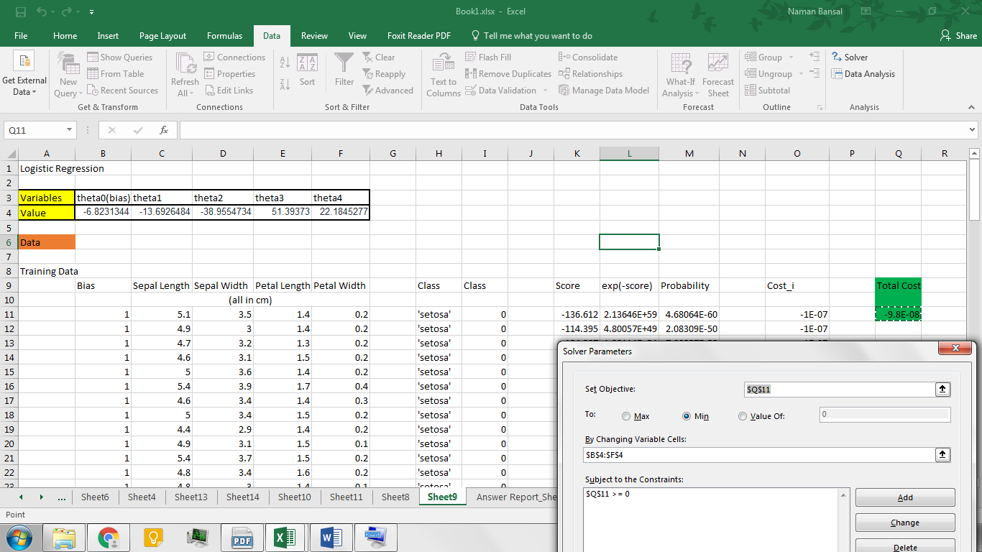

MATLAB Code –

% Non-linear programming  
% Logistic Regression (Classification)  
  
% load the dataset  
load fisheriris  
  
% training data  
X = zeros(70, 4);  
X(1:35, :) = meas(1:35, :); X(36:70, :) = meas(51:85, :);  
y = ones(70, 1); y(1:35) = 0*y(1:35); % labels  
  
% test data  
Xtest = zeros(30, 4);  
Xtest(1:15, :) = meas(36:50, :); Xtest(16:30, :) = meas(86:100, :);  
ytest = ones(30, 1); ytest(1:15) = 0*ytest(1:15);  
  
[m, n] = size(X);  
  
X = [ones(m, 1) X];  
  
% initial value of variables  
initial_theta = zeros(n + 1, 1);  
  
options = optimset('GradObj', 'on', 'MaxIter', 400);  
[theta, cost] = fminunc(@(t)(costFunction(t, X, y)), initial_theta, options);  
  
% Compute accuracy on our training set  
Xtest = [ones(size(Xtest, 1), 1) Xtest];  
p = predict(theta, Xtest);  
  
fprintf('Test Accuracy: %f\n', mean(double(p == ytest)) * 100);

% objective function along with its gradients  
function [J, grad] = costFunction(theta, X, y)  
  
% Initialize some useful values  
m = length(y); % number of training examples  
  
z = X * theta;  
h = sigmoid(z);  
J = ( -1/m ) * sum( y .* log( h ) + ( 1 - y ) .* log( 1 - h ) );  
grad = ( X' * ( h - y ) ) / m;  
  
end

% classification of the test cases  
function p = predict(theta, X)  
p = X*theta;  
p( p >= 0) = 1;  
p( p < 0) = 0;  
  
end

function g = sigmoid(z)  
g = sigmf( z, [ 1, 0 ] );  
  
end

MATLAB Solution –

Accuracy = 100%

Reference –

<https://in.mathworks.com/help/stats/examples/classification.html>

**Example 24 –**

Pump network synthesis problem (Mixed Integer Non-linear Programming)

In this problem, the aim is to identify the least costly configuration of centrifugal pumps that achieves a pre-specified pressure rise based on a given total flowrate. We study a three-level pump super structure as shown below.

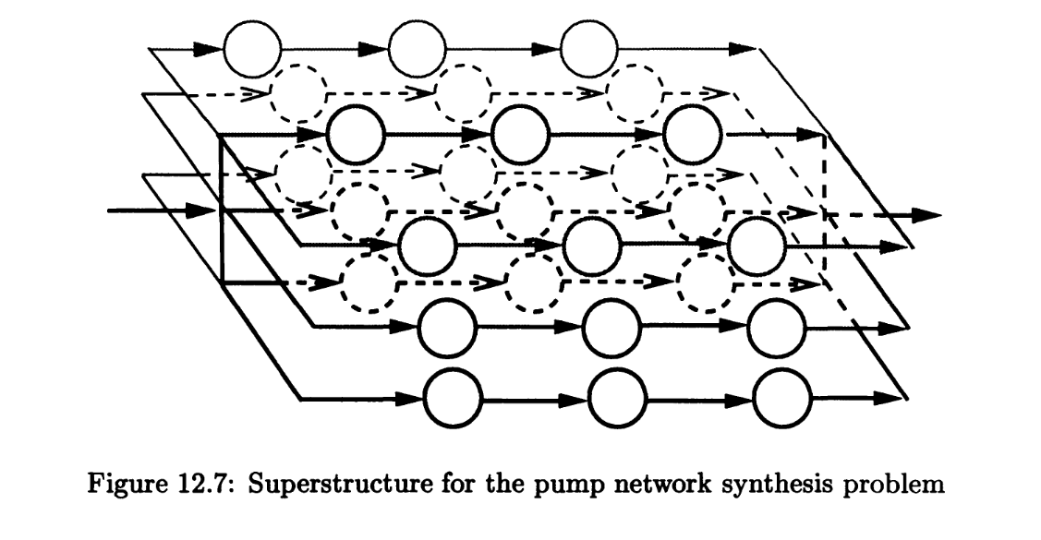

Variable Definition –

The parameters are $V_{tot},$ the total volumetric flowrate through the network, $∆P_{tot}$, the prescribed pressure rise, $w_{max}$*,* the maximum rotation speed of a pump, and $P_{i}^{max}$ *, $i=1, 2, 3,$*  the maximum power requirement for a pump on level $i$.

The binary variables $z_{i}, i=1, …, 3$ denote the existence of level $i$. The integer variables $N_{p_{i}}, i=1, …, 3,$ denote the number of parallel lines at level $i$. The integer variables $N_{p_{i}}, i=1, …, 3,$ denote the number of pumps in series at level $i$.

The continuous variables are the fraction of total flow going to level $i,$ $x_{i},$ the flowrate on each line at level $i,$ $V_{i},$ the rotation speed of all pumps on level $i,$ $w_{i},$ the power requirements at level $i$, $P_{i}$ and the pressure rise at level $i, ∆p_{i}$.

Objective Function –

$$\min_{x, \dot{v,}w,P,∆p,N_{p},N_{s},z}{\sum_{i=1}^{3}{\left(C_{i}+C_{i}^{'}P_{i}\right)N_{p_{i}}N_{s_{i}}z_{i}}}$$

Constraints –

$$P_{1}-19.9{\left(\frac{w_{1}}{w_{max}}\right)}^{3}-0.1610{\left(\frac{w_{1}}{w_{max}}\right)}^{2}{\dot{v}}_{1}+0.000561\left(\frac{w_{1}}{w_{max}}\right){\dot{v}}_{1}^{2}=0$$

$$P_{2}-1.21{\left(\frac{w_{2}}{w_{max}}\right)}^{3}-0.0644{\left(\frac{w_{2}}{w_{max}}\right)}^{2}{\dot{v}}_{2}+0.000564\left(\frac{w_{2}}{w_{max}}\right){\dot{v}}_{2}^{2}=0$$

$$P_{3}-6.52{\left(\frac{w_{3}}{w_{max}}\right)}^{3}-0.1020{\left(\frac{w_{3}}{w_{max}}\right)}^{2}{\dot{v}}_{3}+0.000232\left(\frac{w_{3}}{w_{max}}\right){\dot{v}}_{3}^{2}=0$$

$$∆p_{1}-629{\left(\frac{w_{1}}{w_{max}}\right)}^{2}-0.696\left(\frac{w_{1}}{w_{max}}\right){\dot{v}}_{1}+0.0116{\dot{v}}_{1}^{2}=0$$

$$∆p_{2}-215{\left(\frac{w_{2}}{w_{max}}\right)}^{2}-2.950\left(\frac{w_{2}}{w_{max}}\right){\dot{v}}_{2}+0.115{\dot{v}}_{2}^{2}=0$$

$$∆p_{3}-361{\left(\frac{w_{3}}{w_{max}}\right)}^{2}-0.530\left(\frac{w_{3}}{w_{max}}\right){\dot{v}}_{1}+0.00946{\dot{v}}_{3}^{2}=0$$

$$x_{1}+x_{2}+x_{3}=1$$

$${\dot{v}}_{i}N_{p_{i}}-x_{i}V_{tot}=0, i=1, 2, 3$$

$$∆P_{tot}z_{i}-∆p_{i}N_s_{i}=0, i=1, 2, 3$$

$$w_{i}-w_{max}z_{i}≤0, i=1, 2, 3$$

$$P_{i}-P_{i}^{max}z_{i}≤0, i=1, 2, 3$$

$${∆p}_{i}-{∆P}_{tot}z_{i}≤0, i=1, 2, 3$$

$${\dot{v}}_{i}-V_{tot}z_{i}≤0, i=1, 2, 3$$

$$x_{i}-z_{i}≤0, i=1, 2, 3$$

$${N_{s}}_{i}-3z_{i}≤0, i=1, 2, 3$$

$${N_{p}}_{i}-3z_{i}≤0, i=1, 2, 3$$

Variable Bounds –

$$0≤x_{i}≤1, i=1, 2, 3$$

$$0≤{\dot{v}}_{i}≤V_{tot}, i=1, 2, 3$$

$$0≤w_{i}≤w_{max}, i=1, 2, 3$$

$$0≤P_{i}≤P_{i}^{max}, i=1, 2, 3$$

$$0≤∆p_{i}≤∆P_{tot}, i=1, 2, 3$$

$$N_{p_{i}}∈\left\{0, 1, 2, 3\right\}, i=1, 2, 3$$

$${N_{s}}_{i}∈\left\{0, 1, 2, 3\right\}, i=1, 2, 3$$

$$z_{i}∈\left\{0, 1\right\}, i=1, 2, 3$$

Data –

|  |  |  |
| --- | --- | --- |
|  |  |  |
|  |  |  |

|  |  |  |  |
| --- | --- | --- | --- |
|  | Pump 1 | Pump 2 | Pump 3 |
| Fixed Cost (FIM) | 38900 | 15300 | 20100 |
| $C_{i}$ (FIM) | 6329.03 | 2489.31 | 3270.27 |
| $C_{i}^{'}$ (FIM/kW) | 1800 | 1800 | 1800 |

Excel Solution –

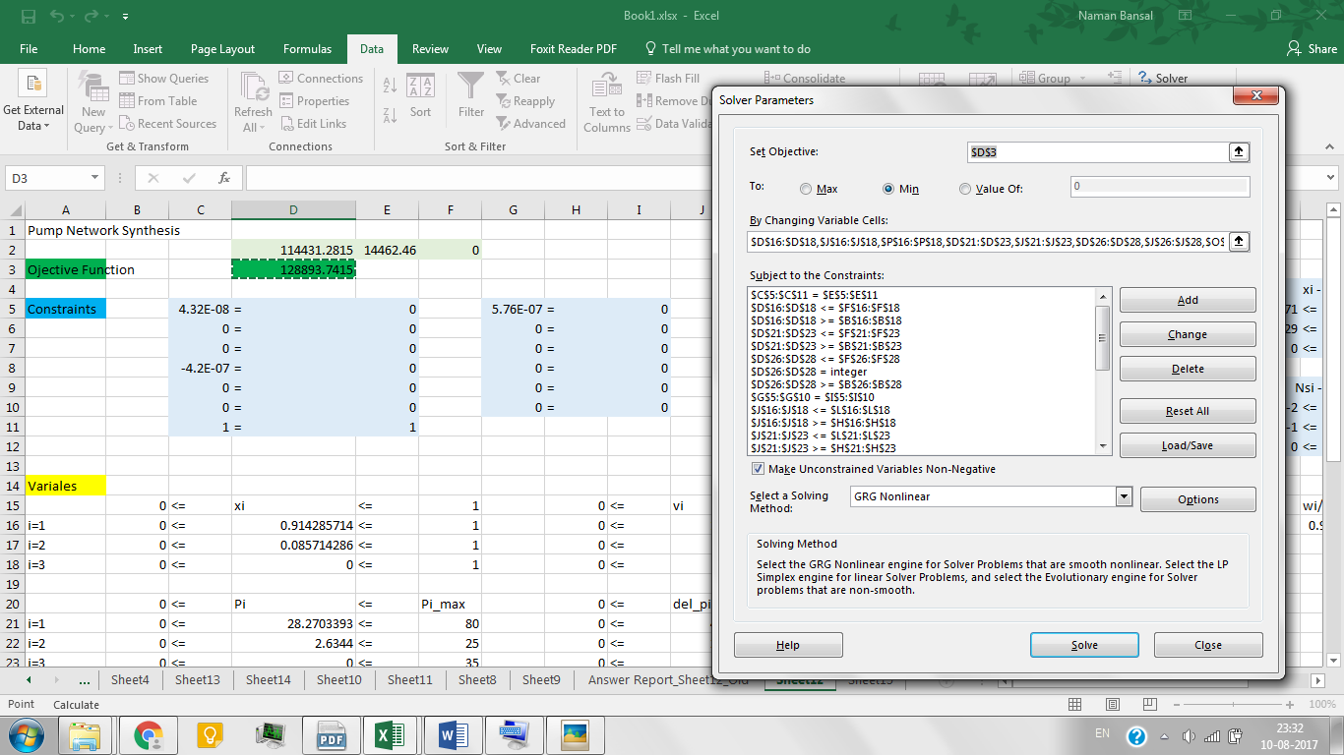

MATLAB Code –

function E24_PumpConfig  
% Mixed integer Non-linear Programming  
% Pump Network Synthesis Problem  
  
Vtol = 350; wmax = 2950; Pmax = [80; 25; 35]; delP_tol = 400;  
  
% Objective Function  
fun = @Pump_fun;  
  
% non-linear constraints  
nlcon = @Pump_nonlcon;  
nlrhs = [zeros(12, 1)];  
nle = [ zeros(12, 1 ) ]; % -1 for <=, 0 for == and 1 for >=  
  
nvars = 24;  
  
% Aeq*x <= beq  
Aeq = sparse( [ones(1, 3) zeros(1, 21)] ); % x1 + x2 +x3 = 1  
beq = [1];  
  
% A*x <= b  
A = sparse( ...  
 [ zeros(1, 6), 1, 0, 0, zeros(1, 12), -wmax, 0, 0;... % w1 - wmax*z1 <=0  
 zeros(1, 6), 0, 1, 0, zeros(1, 12), 0, -wmax, 0;... % w2 - wmax*z2 <=0  
 zeros(1, 6), 0, 0, 1, zeros(1, 12), 0, 0, -wmax;... % w3 - wmax*z3 <=0  
  
 zeros(1, 9), 1, 0, 0, zeros(1, 9), -Pmax(1), 0, 0;... % P1 - Pmax1*z1 <=0  
 zeros(1, 9), 0, 1, 0, zeros(1, 9), 0, -Pmax(2), 0;... % P2 - Pmax2*z2 <=0  
 zeros(1, 9), 0, 0, 1, zeros(1, 9), 0, 0, -Pmax(3);... % P3 - Pmax3*z3 <=0  
  
 zeros(1, 12), 1, 0, 0, zeros(1, 6), -delP_tol, 0, 0;... % delP1 - delP_tol*z1 <=0  
 zeros(1, 12), 0, 1, 0, zeros(1, 6), 0, -delP_tol, 0;... % delP2 - delP_tol*z2 <=0  
 zeros(1, 12), 0, 0, 1, zeros(1, 6), 0, 0, -delP_tol;... % delP3 - delP_tol*z3 <=0  
  
 zeros(1, 3), 1, 0, 0, zeros(1, 15), -Vtol, 0, 0;... % vdot1 - Vtol*z1 <=0  
 zeros(1, 3), 0, 1, 0, zeros(1, 15), 0, -Vtol, 0;... % vdot2 - Vtol*z2 <=0  
 zeros(1, 3), 0, 0, 1, zeros(1, 15), 0, 0, -Vtol;... % vdot3 - Vtol*z3 <=0  
  
 1 zeros(1, 20) -1 0 0; ... % x1 - z1 <= 0  
 0 1 zeros(1, 20) -1 0; ... % x2 - z2 <= 0  
 0 0 1 zeros(1, 20) -1; ... % x3 - z3 <= 0  
  
 zeros(1, 18) 1 0 0 -3 0 0; ... % Ns1 - 3z1 <= 0  
 zeros(1, 18) 0 1 0 0 -3 0; ... % Ns2 - 3z2 <= 0  
 zeros(1, 18) 0 0 1 0 0 -3; ... % Ns3 - 3z3 <= 0  
  
 zeros(1, 15) 1 0 0 0 0 0 -3 0 0; ... % Np1 - 3z1 <= 0  
 zeros(1, 15) 0 1 0 0 0 0 0 -3 0; ... % Np2 - 3z2 <= 0  
 zeros(1, 15) 0 0 1 0 0 0 0 0 -3] ); % Np3 - 3z3 <= 0  
b = [zeros(21, 1)];  
  
% bounds on variables  
lb = zeros(24, 1);  
ub = ones(24, 1);  
ub(4:6) = Vtol*ub(4:6); ub(7:9) = wmax*ub(7:9);  
ub(10:12) = Pmax.*ub(10:12); ub(13:15) = delP_tol*ub(13:15);  
ub(16:18) = 3*ub(16:18); ub(19:21) = 3*ub(19:21);  
  
% integer constraints (variables listed in intcon takes integral values)  
xtype = [ repmat('C', 1, 15) ,repmat('I', 1, 6), repmat('B', 1, 3) ];  
  
% initial value  
y0 = lb;  
  
%Specify to use the COIN-OR LP solver CLP  
%opts = optiset('solver','SCIP');  
opts = optiset('solver','SCIP', 'maxiter', 1.5e9, 'maxfeval', 1e50, ...  
 'maxnodes', 1e9, 'maxtime', 1e20, 'tolafun', 1e-4, ...  
 'tolint', 1e-4, 'warnings', 'critical', 'display', 'iter', 'derivCheck', 'off');  
  
% Create OPTI Object  
Opt = opti('fun', fun, 'nlmix', nlcon, nlrhs, nle, 'eq', Aeq, beq, 'ineq', A, b,'bounds', lb, ub,...  
 'xtype', xtype, 'ndec', 24, 'options', opts)  
  
  
[x, fval, exitflag, info] = solve(Opt, y0)  
  
end  
  
% objective function  
function [fval] = Pump_fun(y)  
  
C = [6329.03, 2489.31, 3270.27];  
Cprime = [1800, 1800, 1800];  
  
fval = ( ( C(1) + Cprime(1)*y(10) )*y(16)*y(19)*y(22) ) + ...  
 ( ( C(2) + Cprime(2)*y(11) )*y(17)*y(20)*y(23) ) + ...  
 ( ( C(3) + Cprime(3)*y(12) )*y(18)*y(21)*y(24) );  
end  
  
% non-linear constraints  
function c = Pump_nonlcon(y)  
  
% variable definition  
x = y(1:3); vdot = y(4:6); w = y(7:9); P = y(10:12); delP = y(13:15); Np = y(16:18); Ns = y(19:21); z = y(22:24);  
Vtol = 350; wmax = 2950; Pmax = [80, 25, 35]; delP_tol = 400;  
  
wprime = w/wmax;  
  
c = [ ( P(1) - 19.9*wprime(1)^3 - 0.1610*(wprime(1)^2)*vdot(1) + 0.000561*wprime(1)*vdot(1)^2 );...  
  
 ( P(2) - 1.21*wprime(2)^3 - 0.0644*(wprime(2)^2)*vdot(2) + 0.000564*wprime(2)*vdot(2)^2 );...  
  
 ( P(3) - 6.52*wprime(3)^3 - 0.1020*(wprime(3)^2)*vdot(3) + 0.000232*wprime(3)*vdot(3)^2 );...  
  
 ( delP(1) - 629*wprime(1)^2 - 0.696*wprime(1)*vdot(1) + 0.0116*vdot(1)^2 );...  
  
 ( delP(2) - 215*wprime(2)^2 - 2.950*wprime(2)*vdot(2) + 0.115*vdot(2)^2 );...  
  
 ( delP(3) - 361*wprime(3)^2 - 0.530*wprime(3)*vdot(3) + 0.00946*vdot(3)^2 );...  
  
 ( vdot(1)*Np(1) - x(1)*Vtol );...  
  
 ( vdot(2)*Np(2) - x(2)*Vtol );...  
  
 ( vdot(3)*Np(3) - x(3)*Vtol );...  
  
 ( delP_tol*z(1) - delP(1)*Ns(1) );...  
  
 ( delP_tol*z(2) - delP(2)*Ns(2) );...  
  
 ( delP_tol*z(3) - delP(3)*Ns(3) );...  
 ];  
  
end

MATLAB Solution –

Reference –

Floudas, Christodoulos A., et al. *Handbook of test problems in local and global optimization*. Vol. 33. Springer Science & Business Media, 2013.

(Chapter 12, Section 12.5.2, Test Problem 1)

**Example 25** **–**

Trim loss minimization problem (Mixed Integer Non-linear programming)

Trim loss minimization problems arise in the paper cutting industry. The main task is to cut out some paper products of different sizes from a large raw paper roll, in order to meet a customer's order.

General Problem Formulation –

Variable Definition –

Each product paper roll is characterized by its width $b$. All product rolls are assumed to be of equal length. The raw paper roll has a width $B_{max}$. In general, it is not possible to cut out an entire order without throwing away some of the raw paper. The optimum cutting scheme minimizes the waste paper or trim roll. In order to identify the best overall scheme, a maximum number of different cutting patterns $P$ is postulated, where a pattern is defined by the position of the knives. Each cutting pattern may have to be repeated several times in the overall scheme to meet the demand. There are $N$ different product sizes and $n_{i}$ rolls of size $b_{i}$ must be cut. The existence of each pattern is denoted by binary variable $z_{j}, j=1, …, P$. The number of repeats of pattern $j$ is denoted by the integer variable $m_{j}$. The number of products of size $i$ in pattern $j$ is given by the integer variable $r_{ij}$.

Objective Function –

$$\min_{m, y, r}{\sum_{j=1}^{P}{m_{j}+0.1jy_{j}}}$$

Constraints –

*There is printing mistake in the book in all the test problems under Trim Loss minimization section. Please refer to the very first equation of this section for your reference. (I have corrected it in my code and also highlighted the correction.)

$$\sum_{j}{m_{j}r_{ij}}≥n_{i}, i=1, …, N$$

$$\left(B_{max}-∆\right)y_{j}-\sum_{i}{b_{j}r_{ij}}≤0, j=1, …, P$$

$$\sum_{i}{b_{j}r_{ij}}-B_{max}y_{j}≤0, j=1, …, P$$

$$y_{j}-\sum_{i}{r_{ij}}≤0, j=1, …, P$$

$$\sum_{i}{r_{ij}}-Nk_{max}y_{j}≤0, j=1, …, P$$

$$y_{j}-m_{j}≤0, j=1, …, P$$

$$m_{j}-M_{j}y_{j}≤0, j=1, …, P$$

$$\sum_{j}{m_{j}}≥\max\left\{\left\lceil \frac{\sum_{i}{n_{i}}}{Nk_{max}}\right\rceil , \left\lceil \frac{\sum_{i}{{b_{i}n}_{i}}}{B_{max}}\right\rceil \right\}$$

$$y_{k+1}-y_{k}≤0, k=1, …, P-1$$

$$m_{k+1}-m_{k}≤0, k=1, …, P-1$$

Variable Bounds –

$$y_{j}∈\left\{0, 1\right\}, j=1, …,P$$

$$m_{j}∈\left\{0, M_{j}\right\}∩N, j=1, …,P$$

$$r_{ij}∈\left\{0, Nk_{max}\right\}∩N, i=1, …,N, j=1, …,P$$

Excel Solution –

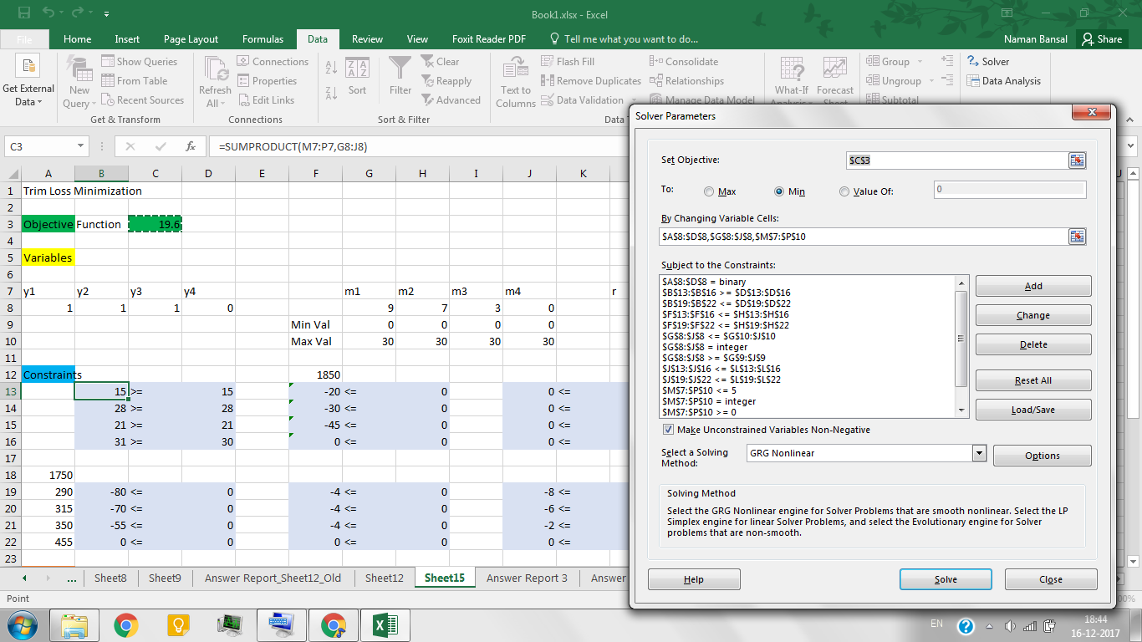

MATLAB Code –

MATLAB Solution –

Reference –

**Example 26** **–**

Mixed Integer Non-linear programming

The following figure shows the superstructure of a small process plant containing several alternatives for producing product C from raw materials A and/or B. The objective is to maximize profit given that there is a cap on the production of C.

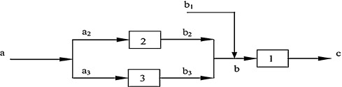

Problem Formulation –

The model for the superstructure can be formulated as the MINLP problem.

Objective Function –

$$\min_{z}{z=3.5y1+y2+1.5y3+7.0b1+b2+1.2b3+1.8a-11.0c}$$

Constraints –

$$b2-\ln\left(1+a2\right)=0$$

$$b3-1.2 ln\left(1+a3\right)=0$$

$$c-0.9b=0$$

$$-b+b1+b2+b3=0$$

$$a-a2-a3=0$$

$$b-5y1≤0$$

$$a2-5y2≤0$$

$$a3-5y3≤0$$

Variable Bounds –

$$c≤1$$

$$b2≤5$$

$$y1,y2,y3∈{\left\{0,1\right\}}^{3}$$

$$a,a2,a3,b,b1,b2,b3,c≥0$$

*The following bounds were not part of the original problem but can be easily derived from the constraints.

$$b,b1,b3≤5$$

$$a≤10$$

$$a1,a2≤5$$

Data –

|  |  |  |
| --- | --- | --- |
| Objective Function: Investment and Operating Costs | | |
| process | fixed cost, 103 $/h | variable cost, 103 $/ton of product |
| 1 | 3.5 | 2.0 |
| 2 | 1.0 | 1.0 |
| 3 | 1.5 | 1.2 |

Raw materials costs, 103 $ = 1.8/ton of a, 7.0/ton of b

Revenue, 103 $ = 13/ton of c with max market demand = 1 ton/h

Z = objective function = costs – revenue (103 $/h)

= (3.5y1 + 2c) + (y2 + b2) + (1.5y3 + 1.2b3) + 1.8a + 7.0b – 13c

= 3.5y1 + y2 + 1.5y3 + 1.8a + 7.0b1 + b2 + 1.2b3 – 11c

Mass Balances –

Process 2: $b2=\log{(1+a2)}$

Process 3: $b3=1.2\log{(1+a3)}$

Process 1: $c=0.9b$

Split to 2 and 3: $a=a2+a3$

Mixer before 1: $b=b1+b2+b3$

Limit on process 2: $b≤5$

Excel Solution –

MATLAB Code –

clc; clear; close all;  
  
% Mixed integer Non-linear Programming  
% Planning Problem  
  
% Objective Function  
fun = @Plan_fun;  
  
% % Variable definition as per the original problem  
%y1 = x(1); y2 = x(2); y3 = x(3);  
%b1 = x(4); b2 = x(5); b3 = x(6);  
%a = x(7); c = x(8);  
%b = x(9);  
%a2 = x(10); a3 = x(11);  
  
% non-linear constraints  
nlcon = @Plan_nonlcon;  
nlrhs = [ zeros(2, 1) ];  
nle = [ zeros(2, 1 ) ]; % -1 for <=, 0 for == and 1 for >=  
  
nvars = 11;  
  
% Aeq*x <= beq  
Aeq = [ 0 0 0 0 0 0 0 1 -0.9 0 0;  
 0 0 0 1 1 1 0 0 -1 0 0;  
 0 0 0 0 0 0 1 0 0 -1 -1 ];  
beq = [ 0; 0; 0 ];  
  
% A*x <= b  
A = [ -5 0 0 0 0 0 0 0 1 0 0;  
 0 -5 0 0 0 0 0 0 0 1 0;  
 0 0 -5 0 0 0 0 0 0 0 1 ];  
b = [ 0; 0; 0 ];  
  
% bounds on variables  
lb = zeros(11, 1);  
ub = [ 1; 1; 1; 5; 5; 5; 10; 1; 5; 5; 5 ]; % Upper limits can be derived from inequalities  
  
% integer constraints (variables listed in intcon takes integral values)  
xtype = [ repmat('B', 1, 3) ,repmat('C', 1, 8) ];  
  
% initial value  
y0 = ub;  
  
%Specify to use the COIN-OR LP solver CLP  
opts = optiset('solver','SCIP', 'maxiter', 1.5e9, 'maxfeval', 1e50, ...  
 'maxnodes', 1e9, 'maxtime', 1e20, 'tolafun', 1e-4, ...  
 'tolint', 1e-4, 'warnings', 'critical', 'display', 'iter', 'derivCheck', 'off');  
  
% Create OPTI Object  
Opt = opti('fun', fun, 'nlmix', nlcon, nlrhs, nle, 'ineq', A, b, 'eq', Aeq, beq, 'bounds', lb, ub,...  
 'xtype', xtype, 'ndec', 11, 'options', opts)  
  
[x, fval, exitflag, info] = solve(Opt, y0)

MATLAB Solution –

$$\left[y1,y2,y3,b1,b2,b3,a,c\right]≤\left[1.0000, 0, 1.0000, 0, 0, 1.1111, 1.5242, 1.0000\right]$$

Reference –

Shokrian, Mazdak, and Karen Ann High. "Application of a multi objective multi-leader particle swarm optimization algorithm on NLP and MINLP problems." *Computers & Chemical Engineering* 60 (2014): 57-75.

Kocis, Gary R., and Ignacio E. Grossmann. "Relaxation strategy for the structural optimization of process flow sheets." *Industrial & engineering chemistry research* 26.9 (1987): 1869-1880.

1. * This is due to the tolerance limit of the ‘*ga*’ function.